##### 9008 Meisner Road, Casco, MI 48064 / [www.ourstjameschurch.org/](http://www.ourstjameschurch.org/)

Newsletter

July/August 2021

Volume 7, Issue 7



Greetings to all.

Now that seem to be making our way through what has been another interesting year. I am glad to see that family and friends are starting to gather and share time together. This time of isolation has been difficult for many. I hope you are enjoying the summer.

As I look around, I am delighted to see the gardens have exploded with all kinds of wonderful color and fragrances. I am excited about the new activity and helping hands taking part in shaping my gardens. I am thrilled that summer is here and the long winter is behind us. It is a glorious summer.

Personally, July is for me a rich time of reflection and gratitude reflecting on times of major transformation in my life. As we start the back half of the year, I am reminded to embrace each new day with all the opportunities, challenges, and times of profound spiritual enlightenment that every new day can bring. As one journey ends a new and exciting one begins.

I am hoping that for you this summer is a time of reflecting and relaxing. For some of you it will be a time of graduations, weddings, vacations, get-a-ways, and trips to the beach. I offer traveling mercies to you all, wherever this summer’s adventures take you.

Remember to stop into a local church and say hello and share with them about your home church and how God has touched your life. One of my fond memories as kids was my mother always had us stop by churches wherever and whenever we were visiting places to go in just say a little prayer and look around. She would say that it was important so when the day came to meet God face to face, he would recognize us and remember we had stopped by to say hello.

https://www.facebook.com/St-James-United-Church-of-Christ-10150090210425008/

Contents

News from Pastor Ken 1

Pastor Ken News Cont. 2

Prayers Needed 3

Outreach Ministry 3

Birthday 4

Anniversary 4

Spiritual Ministry 4

Discretionary Fund 4

Earthly Gift Ministry 4

Fourth of July Tribute 5

Christmas Tote Bags 6

Ministers Needed 6

Bottle Can Collection 6

Military Prayer List 6

Kid’s Page 7

Activities 8

Scripture Readings 9



# News from Pastor Ken

The purpose of a newsletter is to provide specialized information to a targeted audience. A school newsletter can be a great way to develop a strong relationship with parents.

First choose a short title for your newsletter— something like "School News," or “Back to School.” As you choose the title, also take time to think about the newsletter’s theme. What important messages do you want to send parents and families?

Next, establish how much time and money you can spend on your newsletter. These factors will help determine how frequently you publish the newsletter and its length.

Use the body of your school newsletter to keep parents apprised of major assignments and class events, as well as any of school district news. Also share news for specific grade levels, and tell parents about upcoming events, new faculty, and school policies.

## Dear Parents

St. James United Church of Christ

**Pastor Ken Newsletter Continued**

That funny little story still has me stopping by churches whenever I am on the road whether traveling for pleasure or for work.

For some of us this has been a difficult and challenging summer dealing with issues of health, money, loss or just life on life’s terms. Perhaps even to the point of trying our faith. Please know that you are not on this journey alone. God is always with us and makes God’s presence known by surrounding us with friends, family (and as I like to say, some I am related to) and the occasional encounter with a stranger that God sends along to deliver a message. I genuinely believe that God is with me the most when times are hardest and I feel it the least. My history is proof. I believe it to be true for you as well.

Others of us are just laying low enjoying those laid-back days of summer. Remember that list of everything we were going to do this summer…relax a little. The list is always bigger than the time and energy to do it. Do what you can but remember to enjoy.

As we spend the summer relaxing and having fun, we have so much to look forward to with a new season of worship and spiritual growth. May your summer be a restful, revitalizing time, Spirit-filled and surrounded by the grace and love of God. And remember that regardless of where the summer takes you, you are held in God’s unconditional love, boundless mercy, and unending grace and there is a place for you here. Have a great summer. See you Sunday!

Take care and be well, Peace

Ken

**\*\*Live streaming of Sunday Services will continue at 9:00am on the St. James Facebook page and at 11:00am on St. Johns Facebook page. Both will be available by video once live streaming is completed.\*\***

**Page 2 of 9**



Prayers for …. Claudette, Linda, Wayne B., Shirley, Carole, Deborah, Karen, Keith, Terry, Janette, Barb, David, Lynn, Nikki, Ralph, Sue, Frazer, Lee, Arnie, Tom, Jennifer, Dennis, Carol, Joy, Jack, Harvey, Lynn, Jim, Karen, Jim M, Don, Lois, Trisha, Tom, Brenda, Bernetta, Joe, Bill, George, Irene, Nelson, Mary F., Nancy H., Ben H., Michelene, Don A, Prange Family, Mary F., Tamara, Families of St. John & St. James

**Prayer List ….**

**Page 3 of 9**

**Outreach Ministry**

Helping Hands

**Current Needs**: Canned fruit, baking mixes (cake, brownie, muffins) Now accepting donations currently.

Not accepting books and furniture currently.

**No expired or opened boxes of food accepted**.

.

**Blue Water Area Rescue Mission** **– B-WARM**

**B-WARM NEEDS**

**Both Men and Women houses:**

No current needs. They are thankful for the church’s support and continued prayers. Continued prayers for Arnie’s continued recovery from COVID and success on restarting their programs.

**Current needs** are as follows:

Boy’s socks size 3-9, adult shampoo and conditioner, adult toothbrushes, deodorant for boys and girls, girls 4T shorts, boys and girls tops and shorts, pj’s all sizes from newborn up, and twin sheets.

**Kids in Distress**

**Happy Anniversaries in August**

**Happy Anniversaries in July**

## Happy Birthdays in July

**Page 4 of 9**

|  |
| --- |
| 2 – Barb Ski |
| 7 – Judy Tringali |
| 7 – Katelyn Strunk |
| 16 – Lynn Robertson |
| 17 – Jerry Lindke |
| 18 – Alexia Teltow |
| 23 – Ralph Ski |
| 25 – Dave Robertson |
| 26 – Bernice Callahan |

|  |
| --- |
| 4 – Julie & Chad Robbins |
| 7 - Sue & Mark Tews |
| 12 - Julie & Frederick Erhardt |
| 19 – Brenda & James Maedel |
| 25 – Mark & Paula Beattie |

|  |
| --- |
| 7 – Kerry & LeAnne Bandlow |
| 25 - Devon & Richie Mao |

**Happy Birthdays in August**

|  |
| --- |
| 2 – Colleen Stover |
| 3 – Kerry Bandlow |
| 4- Sherrie Ingles |
| 6 – Kerin Uppleger |
| 9- Kelly Marie Pauley |
| 12 – Teri Wagner |
| 14 – Dorothy Lomerson |
| 16 – Carole Bryant |
| 19 – Devon Klomp-Mao |
| 20 - Jeremy Geneja |
| 22 – Evan Lyszczyk |
| 27 – Marilyn Beattie |
| 27 - Richie Mao |
| 28 - Terry Edward Pauley |

**Earthly Gifts**

Our goal for donations for July and August is $5852.00 temporarily.  Donations can be made during the service, through Paypal or just dropping a check (no cash) by mail to either the church or me Ralph Ski, 8326 Meisner, Casco, MI 48064.  If you would like contribution envelopes, you do not need to be a member just let our greeters know so envelopes can be provided, at the end of the year a statement will be sent for whatever purpose it may be needed if you provide us a mailing address.

**Spiritual Ministry**

Sunday School is NOT in session until Fall. Please feel free to bring your children to church and partake in the weekly Sunday School classes.

Please contact Sue Tews if you are interested in helping with Sunday school.

**The Discretionary Fund**

**July 4th, 2021**

**August 1st, 2021**

Did you know this fund is utilized to aid with rent, utilities, medical supplies, food, and transportation to doctors, etc.?

This is generated from the loose change collected the first Sunday of each month. Please empty your pockets and change purses that day to meet the needs of our church and community.

Fourth of July Tribute!

**Page 5 of 9**



**Page 6 of 9**

**Christmas Tote Bags for**

**Local Community Charities**

The items accepted anytime: hats, gloves/mittens, scarves, TOYS, hygiene items such as: toothbrushes, floss, toothpaste, washcloths, headbands, barrettes and bows, socks (boys and girls, and school supplies.

We collect the below items for boys and girls from the age of 2 to 14 years old. Our goal is to **fill 100 tote bags for next Christmas 2021** without running out of items**.**

**July and August** items to collect: Large enough pieces of material to sew tote bags with.

**Ministry Needing Helpers!!!!!**

Members are needed to take the items received for donation to B-Warm, Kids-In-Distress and Helping Hands in Marine City, MI. As you see the boxes/tubs getting full please feel free to help in this ministry by taking the items to the designated places. **Call first**, to make sure they are open for deliveries.

B-Warm Kids-In-Distress Helping Hands

Bev & Gordie Kulman 310 s. Parker St.

1920 24th St 1114 S 7th St Marine City, MI 48039

Port Huron, MI 48060 St. Clair, MI 48079 (810) 765-3848

[(810) 956-0768](https://www.google.com/search?q=blue+water+area+rescue+mission+port+huron+mi&rlz=1C1CHBD_enUS725US725&oq=blue+water+area+rescue+mission&aqs=chrome.1.69i57j0.24248j0j7&sourceid=chrome&ie=UTF-8) [(810) 326-4505](https://www.google.com/search?rlz=1C1CHBD_enUS725US725&ei=j-5pW5X5EJCwsAW8gi4&q=kids+in+distress&oq=kids+in+distress&gs_l=psy-ab.3..0l2.106654.110108.0.110732.16.10.0.6.6.0.127.1111.1j9.10.0....0...1c.1.64.psy-ab..0.16.1140...0i131k1j0i67k1.0.DlX_ayFsvYg)



**Military Prayer List**

I will be including a list in the newsletter of our men and women in the military, to acknowledge those who serve and to pray for their safety. Please submit your love one’s, family member or friend’s name, rank and branch of service to Roberta Fisher to be placed on the list.

**Bottle / Can Collection**

Due to the circumstances right now, we will no longer be taking in actual bottle and cans. We are collecting cash donations from empty and clean bottles and cans you return to the store yourself that have a deposit on them to support our Christian Education Program.

Please bring the cash or a check to church. You may give Roberta Fisher or Ralph Ski the funds to give Betty Robertson. If you are unable to take them back, we will still take them at church for donation. Place them downstairs in the storeroom.

**Kid’s Page**

**Page 7 of 9**

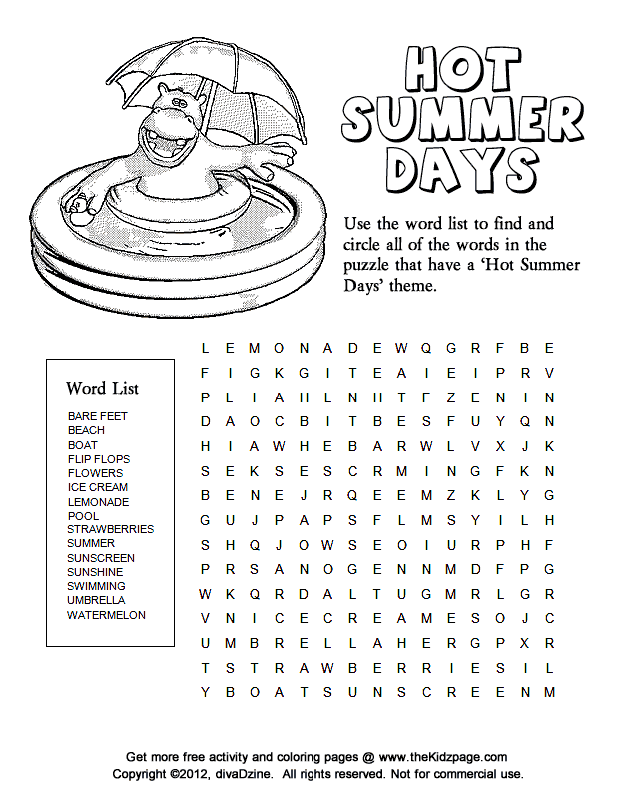

**July Activities**

**Page 8 of 9**

Sunday, July 4 – Sunday Service with Holy Communion – 9:00am

Tuesday, July 13 – In person Council Meeting – 7;00pm

Saturday, July 17 – Euchre – 6:30pm

Sunday, July 18 – Sunday Service with Holy Communion – 9:00am

**August Activities**

Sunday, August 1 – Sunday Service with Holy Communion – 9:00am

Tuesday, August 10 – In person Council Meeting – 7;00pm

Thursday, August 12 – Tent Set-up for Yard Sale – 7:00pm

Friday, August 13 – Set up items for Yard Sale – All Day

Saturday, August 14 – Yard Sale / Bake Sale – 9am to 4pm

Sunday, August 15 – Sunday Service with Holy Communion – 9:00am

Saturday, August 21 – Euchre – 6:30pm

Sunday, August 29 – Sunday Service with Healing – 9:00am

**Scripture Readings for July**

**Page 9 of 9**

**Sunday, July 4 Sunday, July 11**

**Sixth Sunday after Pentecost Seventh Sunday after Pentecost**

2 Sam 5: 1-5, 9-10 2 Sam 6;1-5, 12b-19

Ps 48 Ps 24

Ezek 2: 1-5 and Ps 123 Amos 7: 7-15 and PS 85: 8-13

2 Cor 12: 2-10 Eph 1: 3-14

Mk 6: 1-13 MK 6: 14-29

**Sent with Power**  **God-Inspired Joy**

**Sunday, July 18 Sunday, July 25**

**Eighth Sunday after Pentecost Ninth Sunday after Pentecost**

2 Sam 7: 1-14a 2 Sam 11; 1-15

Ps 89:20-37 Ps 14

Jer 23: 1-6 and Ps 23 2 Kings 4: 42-44 and Ps 145: 10-18

Eph 2: 11=22 Eph 3: 14-21

MK 6: 30-34, 53-56 Jn 6: 1-21

**Wherever You Are God’s Abundant Presence**

**Scripture Readings for August**

**Sunday, August 1 Sunday, August 8**

**Tenth Sunday after Pentecost Eleventh Sunday after Pentecost**

2 Sam 11: 26-12: 13a 2 Sam 18: 5-9, 15, 31-33Ps

51: 1-12 Ps 130

Ex. 16; 2-4, 9-15 and Ps 78: 23-29 1 Kings 19: 4-8 and Ps 34: 1-8

Eph 4: 1-16 Eph 4: 25-5:2

Jn 6: 24-35 Jn 6: 35, 41-51

**Bread of Life**  **Shaping Community**

**Sunday, August 15 Sunday, August 22**

**Twelfth Sunday after Pentecost Thirteenth Sunday after Pentecost**

1 Kings 2: 10-12, 3; 3-14 1 Kings 8: (1,6, 10-11) 22-30, 41-34

Ps 111 Ps 84

Prov 9: 1-6 and Ps 34: 9-14 Josh 24: 1-2a, 14-18, & Ps 34: 15-22

Eph 5: 15-20 Eph 6: 10-20

Jn 6: 51-58 John 6: 56-69

**Wisdom Quest At Home with God**

**Sunday, August 29**

**Fourteenth Sunday after Pentecost**

Song of Sol 2: 8-13

Ps 45: 1-2, 6-9

Dut 4: 2, 6-9 and Ps 15

James 1: 17-27

Mk 7: 1-8 14-15, 21-23



**St. James United Church of Christ**

**9008 Meisner Road**

**Casco, MI 48064**

**Phone:**

(586) 727--1623

**Fax:**

(586) 27-0833

**E-mail:**

kgadd@ourstjameschurch.org



JULY / AUGUST

NEWSLETTER