##### 9008 Meisner Road, Casco, MI 48064 / [www.ourstjameschurch.org/](http://www.ourstjameschurch.org/)

Newsletter

June 2021

Volume 6, Issue 6

Contents

News from Pastor Ken 1

Pastor Ken News Cont. 2

Prayers Needed 3

Outreach Ministry 3

Birthday 4

Anniversary 4

Spiritual Ministry 4

Discretionary Fund 4

Earthly Gift Ministry 4

Father’s Day Poem 5

Christmas Tote Bags 6

Ministers Needed 6

Bottle Can Collection 6

Military Prayer List 6

Kid’s Page 7

Activities 8

Scripture Readings 8

Summertime, Summertime! People are actually starting to come out of seclusion and are talking about vacations, weddings, family reunions, and fun on the water. To say nothing about the fact that the gardens are bursting, the birds are chirping, and everyone seems just a little happier. Must be the vitamin D.

I do so enjoy finally having morning prayers and meditation outside on the deck. With a couple cups of coffee or tea, of course.

Something about summer seems to give us permission to take a deep breath, smell the roses (literally and figuratively) and give our minds, bodies and spirits a moment to simply be. Slow down, plan a day trip, go to the beach or anywhere, sit lazily under a tree and read, or simply enjoy some log awaited time with family and friends.

I have found the challenge for me, and maybe for you, is to not rush through the relaxation. Just be present and enjoy. You know that long list of things you need to get done this summer. I have learned to start the summer accepting the fact that the list of things I want to do is longer than the summer is. So, get done what you can but not at the expense of having some time for yourself.

Summer is a time of regeneration, discovery, and of transformation. The summer is full of exciting opportunities such as graduations, weddings, and road trips. It can also be a challenging time for some. Life certainly seems to be full of interesting journeys. Whatever the summer holds for us, know that we lift each other up and keep each other in our hearts and in our prayers.

It always amazes me that even as the church year winds down, some of you are already busy planning and getting ready for the fall church calendar. So many of you are busy in selfless ministry. Please remember to take time to breathe and enjoy. This includes Music, Sunday School, outings, fun activities, fellowship and outreach, meals, events, coffee hours, keeping the inside and outside of the property well cared for, bulletins and newsletters published, and on and on and on. Makes me want to rest just thinking about how hard you all work. A BIG thank you to all of you.



https://www.facebook.com/St-James-United-Church-of-Christ-10150090210425008/

# News from Pastor Ken

The purpose of a newsletter is to provide specialized information to a targeted audience. A school newsletter can be a great way to develop a strong relationship with parents.

First choose a short title for your newsletter— something like "School News," or “Back to School.” As you choose the title, also take time to think about the newsletter’s theme. What important messages do you want to send parents and families?

Next, establish how much time and money you can spend on your newsletter. These factors will help determine how frequently you publish the newsletter and its length.

Use the body of your school newsletter to keep parents apprised of major assignments and class events, as well as any of school district news. Also share news for specific grade levels, and tell parents about upcoming events, new faculty, and school policies.

## Dear Parents

St. James United Church of Christ

**Page 2 of 8**

It is nice to take a well-deserved break and allow things to be just a little more casual. As we venture off for a time of reflection, vacations, and summer fun, remember that wherever you are, God is there also. So, when you have an opportunity, stop in other churches along the road and say “hello”. Wherever you are, God is always happy to see you. And when you are back in town, we look forward to seeing you.

Remember that regardless of where the summer takes you, you are held in God’s unconditional love, boundless mercy, and unending grace and there is a place for you here. Have a great first month of summer. I look forward to sharing the summer with you.

Take care and be well, Peace

Ken

**\*\*Live streaming of Sunday Services will continue at 9:00am on the St. James Facebook page and at 11:00am on St. Johns Facebook page. Both will be available by video once live streaming is completed.\*\***

**Pastor Ken Newsletter Continued**



Prayers for …. Claudette, Linda, Wayne B., Shirley, Carole, Deborah, Karen, Keith, Terry, Janette, Barb, David, Lynn, Nikki, Ralph, Sue, Katie, Frazer, Lee, Arnie, Tom, Jennifer, Dennis, Joy, Harvey, Lynn, Sally, Shirley, Jim M, Marian M., Debbie V., Don, Lois, Trisha, Tom, Brenda, Bernetta, Joe, Prange Family, Linda, Ron, Jack L., John G., Ben H., Michelene, Phillis, Families of St. John & St. James



**Prayer List ….**

**Page 3 of 8**

**Outreach Ministry**

Helping Hands

**Current Needs**: Canned fruit, baking mixes (cake, brownie, muffins) Now accepting donations currently.

Not accepting books and furniture currently.

**No expired or opened boxes of food accepted**.

.

**Blue Water Area Rescue Mission** **– B-WARM**

**B-WARM NEEDS**

**Both Men and Women houses:**

No current needs. They are thankful for the church’s support and continued prayers. Continued prayers for Arnie’s continued recovery from COVID and success on restarting their programs.

**Current needs** are as follows:

Boy’s socks size 3-9, adult shampoo and conditioner, adult toothbrushes, deodorant for boys and girls, girls 4T shorts, boys and girls tops and shorts, pj’s all sizes from newborn up, and twin sheets.

**Kids in Distress**

**Happy Anniversaries in June**

## Happy Birthdays in June

**Page 4 of 8**

|  |
| --- |
| 2 – Larry Bandlow |
| 5 – Doris Doss |
| 7 - Wayne Ingles |
| 10 – Mike Lindke |
| 10 – Betty Robertson |
| 11 – Ian Riley |
| 21 – Elise Lyszczyk |
| 24 - Joan Teltow |
| 30 – Erin Riley |

|  |
| --- |
| 7 –Carole & Al Bryant |
| 7 – Sue & Mark Tews |
| 9 - Amy & Trevor Friedeberg |
| 12 – Dave & Lynn Robertson |
| 25 – Teri & Bob Wagner |
| 28 – Art & Cheryl Wagner |

**Spiritual Ministry**

Sunday School is NOT in session until Fall. Please feel free to bring your children to church and partake in the weekly Sunday School classes.

Please contact Sue Tews if you are interested in helping with Sunday school.

**Earthly Gifts**

Our goal for donations for May is $5852.00 temporarily.  Donations so far were $3785.00 and an additional $324.75 raised at the Euchre event.  Thanks to all for your regular donation and those that enjoyed an evening at Euchre.  These donations will help meet or financial obligations.  Donations can be made during the service, through Paypal or just dropping a check (no cash) by mail to either the church or me Ralph Ski, 8326 Meisner, Casco, MI 48064.  Mail is checked daily to keep donations as safe as possible.

**The Discretionary Fund**

**June 6th, 2021**

Did you know this fund is utilized to aid with rent, utilities, medical supplies, food, and transportation to doctors, etc.?

This is generated from the loose change collected the first Sunday of each month. Please empty your pockets and change purses that day to meet the needs of our church and community.

Father’s Day!

**Page 5 of 8**

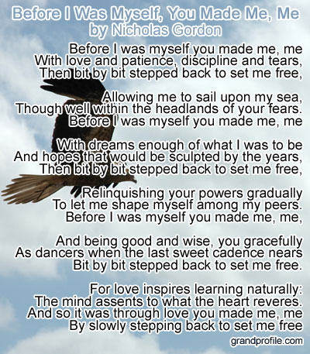

**Page 6 of 8**

**Christmas Tote Bags for**

**Local Community Charities**

The items accepted anytime: hats, gloves/mittens, scarves, TOYS, hygiene items such as: toothbrushes, floss, toothpaste, washcloths, headbands, barrettes and bows, socks (boys and girls, and school supplies.

We collect the below items for boys and girls from the age of 2 to 14 years old. Our goal is to **fill 100 tote bags for next Christmas 2021** without running out of items**.**

**June** items to collect are toothpaste, floss, scissors, and rulers.

**Ministry Needing Helpers!!!!!**

Members are needed to take the items received for donation to B-Warm, Kids-In-Distress and Helping Hands in Marine City, MI. As you see the boxes/tubs getting full please feel free to help in this ministry by taking the items to the designated places. **Call first**, to make sure they are open for deliveries.

B-Warm Kids-In-Distress Helping Hands

Bev & Gordie Kulman 310 s. Parker St.

1920 24th St 1114 S 7th St Marine City, MI 48039

Port Huron, MI 48060 St. Clair, MI 48079 (810) 765-3848

[(810) 956-0768](https://www.google.com/search?q=blue+water+area+rescue+mission+port+huron+mi&rlz=1C1CHBD_enUS725US725&oq=blue+water+area+rescue+mission&aqs=chrome.1.69i57j0.24248j0j7&sourceid=chrome&ie=UTF-8) [(810) 326-4505](https://www.google.com/search?rlz=1C1CHBD_enUS725US725&ei=j-5pW5X5EJCwsAW8gi4&q=kids+in+distress&oq=kids+in+distress&gs_l=psy-ab.3..0l2.106654.110108.0.110732.16.10.0.6.6.0.127.1111.1j9.10.0....0...1c.1.64.psy-ab..0.16.1140...0i131k1j0i67k1.0.DlX_ayFsvYg)



**Military Prayer List**

I will be including a list in the newsletter of our men and women in the military, to acknowledge those who serve and to pray for their safety. Please submit your love one’s, family member or friend’s name, rank and branch of service to Roberta Fisher to be placed on the list.

**Bottle / Can Collection**

Due to the circumstances right now, we will no longer be taking in actual bottle and cans. We are collecting cash donations from empty and clean bottles and cans you return to the store yourself that have a deposit on them to support our Christian Education Program.

Please bring the cash or a check to church. You may give Roberta Fisher or Ralph Ski the funds to give Betty Robertson. If you are unable to take them back, we will still take them at church for donation. Place them downstairs in the storeroom.

**Kid’s Page**

**Page 7 of 8**

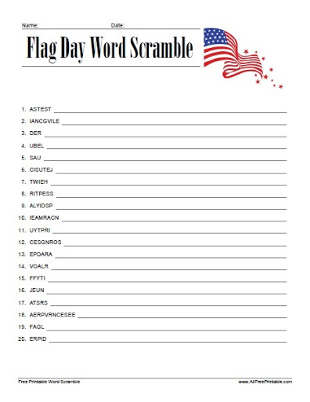

**June Activities**

**Page 8 of 8**

Sunday, June 6 – Sunday Service with Holy Communion – 9:00am

Sunday, June 13 – Sunday Service – 9:00am

Monday, June 14 – Flag Day

Tuesday, June 15 – In person Council Meeting – 7;00pm

Sunday, June 20 – Sunday Service with Holy Communion – 9:00am

Father’s Day Breakfast after service

Sunday, June 27 – Sunday Service – 9:00am

## Scripture Readings for June

**Sunday, June 6 Sunday, June 13**

**Second Sunday after Pentecost Third Sunday after Pentecost**

1 Sam 8: 4-11, (12-15), 16-20, (11:14-15) 1 Sam 15: 34- 16: 13

Ps 138 Ps 20

Gen 3: 8-15 Ezek 17: 22-24 and Ps 92: 1-4, 12-15

2 Cor 4: 13-5:1 2 Cor 5; 6-10, (11-13), 14-17

Mk 3: 20-35 MK 4: 26-34

**God’s Will**  **Flourishing**

**Sunday, June 20 Sunday, June 27**

**Fourth Sunday after Pentecost Fifth Sunday after Pentecost**

1 Sam 17: (1a, 4-11, 19-23), 32-49 2 Sam 1; 1, 17-27

Ps 49 Ps 130

1 Sam 17: 57-18;5, 18; 10-16 Wisdof Sol 1: 13-15, 2: 23-24

Ps, 133 LM 3: 22-33

Job 38: 1-11 Ps 30

Ps 107: 1-3, 23-32 2 Cor 8; 7-15

2 Cor 8: 7-15 MK 5:21-43

Mk 4: 35-41 **Healing Powers**

**Pushing the Boat Out**

**St. James United Church of Christ**

**9008 Meisner Road**

**Casco, MI 48064**

**Phone:**

(586) 727--1623

**Fax:**

(586) 27-0833

**E-mail:**

kgadd@ourstjameschurch.org



June

NEWSLETTER

