##### 9008 Meisner Road, Casco, MI 48064 / [www.ourstjameschurch.org/](http://www.ourstjameschurch.org/)

Newsletter

May 2021

Volume 6, Issue 5

**

I know that everyone has a story for when the weather has been worse or better or different but…. this has been just an odd winter / spring for weather. There was a week when it started in the 60’s and ended in the teens. There has been snow in the middle of April. We have had days that included a little winter and summer all in a day of spring. This weather has been teasing us for over a month.

In spite of it all, I cannot believe how excited I am about the possibility of spring. I cannot wait to spend more time in the yard and in the garden. The gardens seem to be alive already. It is like they could not wait any longer, regardless of the weather. I love watching the gardens come alive.

Taking care of the garden has become a series of great life lessons for me. One of those lessons is that I am still learning to balance the hard work of gardening with remembering to take time to enjoy the garden. I find seeking that balance an interesting metaphor for life. We sometimes get so busy doing life that we forget to enjoy life. However, that being said, I am actually thinking about a couple new garden ideas for this year. They are always a work in progress. As always, we will see how the plan unfolds.

I love the sight, sound and smell of spring, full sensory overload. The garden in early spring serves as a wonderful reminder of all the miracles of life. Just like in our own lives, there is a lot of amazing stuff going on, but because it often happens just below the surface, we sometimes forget to notice it. There exists an amazing opportunity for transition, both in our yards and in our lives. Often where and when we least expect it.

Contents

News from Pastor Ken 1

Pastor Ken News Cont. 2

Prayers Needed 3

Outreach Ministry 3

Birthday 4

Anniversary 4

Spiritual Ministry 4

Worship Ministry 4

Discretionary Fund 4

Earthly Gift Ministry 4

Memorial Day Poem 5

Christmas Tote Bags 6

Ministers Needed 6

Bottle Can Collection 6

Military Prayer List 6

Kid’s Page 7

Activities 8

Scripture Readings 8



https://www.facebook.com/St-James-United-Church-of-Christ-10150090210425008/

# News from Pastor Ken

The purpose of a newsletter is to provide specialized information to a targeted audience. A school newsletter can be a great way to develop a strong relationship with parents.

First choose a short title for your newsletter— something like "School News," or “Back to School.” As you choose the title, also take time to think about the newsletter’s theme. What important messages do you want to send parents and families?

Next, establish how much time and money you can spend on your newsletter. These factors will help determine how frequently you publish the newsletter and its length.

Use the body of your school newsletter to keep parents apprised of major assignments and class events, as well as any of school district news. Also share news for specific grade levels, and tell parents about upcoming events, new faculty, and school policies.

## Dear Parents

St. James United Church of Christ

**Page 2 of 8**

So this Easter season I hope you continue to look for the miracles wherever and whenever they may appear, regardless of how big or how small they may be. Remember, this is truly a season of hope and resurrection. As I work in the garden and experience the joy of new life, my hope is that each of us has the opportunity to experience new life spiritually as well.

With all of challenges that life brings, both in the world and in some of our own homes, it is sometimes hard to remember that God is with us always and at work in our lives. I think that is one of the true miracles of Easter and spring. We are reminded with every winter there comes a season of rebirth and new hope. Sometimes it just takes a while for us to notice it.

So, look around, take a deep breath or two, okay, maybe for some of us three, and know that God is at work in your life right now. Even if you cannot see it or feel it yet, God is preparing you for a personal Easter transformation.

Remember that whoever you are and wherever you are on life’s journey, you are held in God’s unconditional love, boundless mercy, and unending grace and there is a place for you here.

And remember, be kind to yourself.

Take care and be well, Peace

Ken

**\*\*Live streaming of Sunday Services will continue at 9:00am on the St. James Facebook page and at 11:00am on St. Johns Facebook page. Both will be available by video once live streaming is completed..\*\***

**Pastor Ken Newsletter Continued**



Claudette, Linda, Wayne B., Shirley, Carole, Deborah, Karen, Keith, Terry, Janette, Barb, David, Lynn, Rita, Nikki, Vito, Doris, George, Ralph, Sue, Katie, Frazer, Lee, Arnie, Tom, Jennifer, Joy, Sally, Kirsten, Tina, Kathy, Vincent, Tamara, Dort, Don, Lois, Trisha, Harvey, Tom, Brenda, Bernetta, Joe, Jim, Prange Family, Ben H., Michelene, Families of St. John & St. James



**Prayer List ….**

**Page 3 of 8**

**Outreach Ministry**

Helping Hands

**Current Needs:** No current needs at this time.

**No expired or opened boxes of food accepted**

Not accepting books and furniture at this time.

.

**Blue Water Area Rescue Mission** **– B-WARM**

**B-WARM NEEDS**

**Both Men and Women houses:**

No current needs. They are thankful for the church’s support and continued prayers. They’re trying to get back to normal after a year of COVID and family deaths.

**Current needs** are as follows:

Twin comforters, twin sheets, bath towels, hand towels, washcloths, Boys shorts size 5, boys jeans size 7, boys shirts size 6 (clothes new or gently used), boys and girls pajamas size 3 and up, boys and girls shoes, size 4 to 7 (especially size 2 boys), kids and adult toothbrush, toothpaste, baby body wash, shampoo, deodorant, adult body wash.

**Kids in Distress**

|  |
| --- |
| 1 - Bev & Gordie Kulman |
| 2 – Don & Betty Robertson |
| 2 – Bill & Lynnette Osterland |
| 10 – Patti & Jerry Maedel |
| 20 – Mark & Jennifer Uppleger |

**Happy Anniversaries in May**

## Happy Birthdays in May

**Page 4 of 8**

|  |
| --- |
| 1 – Brenda Maedel |
| 2 – Sue Tews |
| 5 – Ellen Riley |
| 9- Shelley Kargula |
| 13 – Bev Kulman |
| 13 - Lisa Mahnke |
| 17 – Chad Teltow |
| 18 – Nancy Maedel |
| 23 – Cindy Klomp |
| 24 – Robert Beattie |
| 24 – Roberta Fisher |
| 27 – Lynn Johnson |
| 29 - Julie Erhardt |
| 31 - Ian Wendt |

**Earthly Gifts**

**Spiritual Ministry**

Sunday School is now in session. Please feel free to bring your children to church and partake in the weekly Sunday School classes.

Please contact Sue Tews if you are interested in helping with Sunday school.

Our goal for donations for April is $5752.00 temporarily. As of the last Sunday our goal was exceeded due to the generosity of our members.  With the donations received last Sunday $6607.00 has been received to exceed the goal plus $264.20 in Euchre profit.  Since we do receive mail donations for the four remaining days of the month, we will not have to count our pennies to meet our upcoming expenses for insurance and regular obligations.  Thanks to everyone for making my position a little easier.  Please remember donations may be made each   Sunday at the service, through PayPal or just dropping a check (no cash) by mail to the church or me Ralph Ski,8326 Meisner, Casco, MI 48064.  Make all checks payable to St. James UCC.  Mail is checked at both location each day, usually shortly after delivery.

**The Discretionary Fund**

**May 2nd, 2021**

Did you know this fund is utilized to aid with rent, utilities, medical supplies, food and transportation to doctors, etc.?

This is generated from the loose change collected the first Sunday of each month. Please empty your pockets and change purses that day to meet the needs of our church and community.

Memorial Day

**Page 5 of 8**

A tribute to our fallen soldiers



**Page 6 of 8**

**Christmas Tote Bags for**

**Local Community Charities**

The items accepted anytime: hats, gloves/mittens, scarves, TOYS, hygiene items such as: toothbrushes, floss, toothpaste, washcloths, headbands, barrettes and bows, socks (boys and girls, and school supplies.

We collect the below items for boys and girls from the age of 2 to 14 years old. Our goal is to **fill 100 tote bags for next Christmas 2021** without running out of items**.**

**May** items to collect are socks, washcloths and toothbrushes.

**Ministry Needing Helpers!!!!!**

Members are needed to take the items received for donation to B-Warm, Kids-In-Distress and Helping Hands in Marine City, MI. As you see the boxes/tubs getting full please feel free to help in this ministry by taking the items to the designated places. **Call first**, to make sure they are open for deliveries.

B-Warm Kids-In-Distress Helping Hands

Bev & Gordie Kulman 310 s. Parker St.

1920 24th St 1114 S 7th St Marine City, MI 48039

Port Huron, MI 48060 St. Clair, MI 48079 (810) 765-3848

[(810) 956-0768](https://www.google.com/search?q=blue+water+area+rescue+mission+port+huron+mi&rlz=1C1CHBD_enUS725US725&oq=blue+water+area+rescue+mission&aqs=chrome.1.69i57j0.24248j0j7&sourceid=chrome&ie=UTF-8) [(810) 326-4505](https://www.google.com/search?rlz=1C1CHBD_enUS725US725&ei=j-5pW5X5EJCwsAW8gi4&q=kids+in+distress&oq=kids+in+distress&gs_l=psy-ab.3..0l2.106654.110108.0.110732.16.10.0.6.6.0.127.1111.1j9.10.0....0...1c.1.64.psy-ab..0.16.1140...0i131k1j0i67k1.0.DlX_ayFsvYg)



**Military Prayer List**

I will be including a list in the newsletter of our men and women in the military, to acknowledge those who serve and to pray for their safety. Please submit your love one’s, family member or friend’s name, rank and branch of service to Roberta Fisher to be placed on the list.

PFC Shane David Kinney Army Airborne

**Bottle / Can Collection**

Due to the circumstances right now, we will no longer be taking in actual bottle and cans. We are collecting cash donations from empty and clean bottles and cans you return to the store yourself that have a deposit on them to support our Christian Education Program.

Please bring the cash or a check to church. You may give Roberta Fisher or Ralph Ski the funds to give Betty Robertson. If you are unable to take them back, we will still take them at church for donation. Place them downstairs in the storeroom.

**Page 7 of 8**

**Kid’s Page**

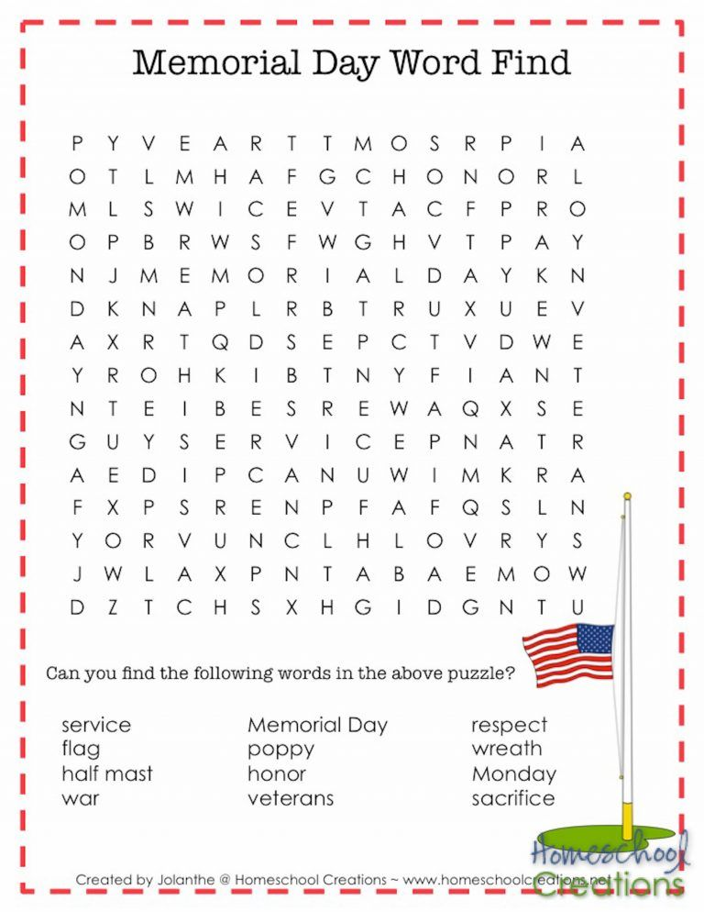

**May Activities**

**Page 8 of 8**

Sunday, May 2 – Sunday Service with Holy Communion – 9am Discretionary Fund Collection

Tuesday, May 11 – Council Meeting – 7pm

Friday, May 14 - Rummage Sale & Bake Sale - 9am – 5pm

Saturday, May 15 - Rummage Sale & Bake Sale - 9am – 3pm

Saturday, May 15 – Euchre at St. James – 6:30pm

Sunday, May 16 – Sunday Service with Holy Communion – 9am.

Sunday, May 30 – Sunday Service with Healing Service – 9am.

Monday, May 31 – Memorial Day

## Scripture Readings for May

**Sunday, May 2 Sunday, May 9**

**Fifth Sunday of Easter Sixth Sunday of Easter**

Acts 8: 26-40 Acts 10: 44-48 Ps 22: 25-31 Ps 98

1 Jn 4: 7-21 1 Jn 5: 1-6

Jn 15: 1-8 Jn 15: 9-17

**Abiding In Love**  **Friends Together**

**Sunday, May 16 Sunday, May 23**

**Seventh Sunday of Easter Pentecost**

Acts 1: 15-17, 21-26 Acts 2: 1-21 or Ezek 37: 1-14

Ps 1 Ps 104: 24-34, 35b

Jn 5: 9-13 Rom 8: 22-27 or Acts 2:1-21

Jn 17: 6-19 Jn 15: 26-27, 16: 4b-15

**Guided in Prayer**  **Spirit for All**

**Sunday, May 30**

**Trinity Sunday**

Isa 6: 1-8

Ps 29

Rom 8: 12-17

Jn 3: 1-17

**Mysterious Encounter**

**St. James United Church of Christ**

**9008 Meisner Road**

**Casco, MI 48064**

**Phone:**

(586) 727--1623

**Fax:**

(586) 27-0833

**E-mail:**

kgadd@ourstjameschurch.org



May

NEWSLETTER

