##### 9008 Meisner Road, Casco, MI 48064 / [www.ourstjameschurch.org/](http://www.ourstjameschurch.org/)

Newsletter

January 2021

Volume 6, Issue 1



Happy New Year!

For many the New Year means a time of new beginnings and hope. I cannot remember a time when so many were so anxious to close the door on the previous year and were ready to welcome the new year.

The New Year can give us a sense of optimism, opportunity and excitement for what the days ahead. It is as if turning to the first page of the calendar allows us to set aside the challenges, disappointments and hurts of the past year and look forward to a fresh beginning.

That is exactly what this past month of Advent and Christmas are all about. Maybe that is why the church calendar always begins approximately a month before our standard secular calendar year. It gives us a little extra time to plan and prepare for this new beginning. It was good this past Advent spending time of active prayer and meditation discerning what God has called me (and us) to do and who God has called me (and us) to be. My hope is that this period of planning and discerning served you well also. And if some how you did not get to it. God allows you to start any time. And start over if you wish.

As we look toward our New Year, I encourage each of us to consider our individual and personal gifts and opportunities and to actively participate in our personal growth and sustainability as well as that of our community of faith. This may include planning and/or growing a ministry, reaching out to those in need, inviting friends and family to attend worship, reaching out to former members or your unchurched neighbors to visit us, encouraging generous giving, and sharing your story of faith in the community.

Contents

News from Pastor Ken 1

Pastor Ken News Cont. 2

Prayers Needed 3

Outreach Ministry 3

Birthday 4

Anniversary 4

Spiritual Ministry 4

Worship Ministry 4

Discretionary Fund 4

Earthly Gift Ministry 4

Happy New Year 5

Christmas Tote Bags 6

Ministers Needed 6

Bottle Can Collection 6

Military Prayer List 6

Kid’s Page 7

Activities 8

Scripture Readings 8



https://www.facebook.com/St-James-United-Church-of-Christ-10150090210425008/

# News from Pastor Ken

The purpose of a newsletter is to provide specialized information to a targeted audience. A school newsletter can be a great way to develop a strong relationship with parents.

First choose a short title for your newsletter— something like "School News," or “Back to School.” As you choose the title, also take time to think about the newsletter’s theme. What important messages do you want to send parents and families?

Next, establish how much time and money you can spend on your newsletter. These factors will help determine how frequently you publish the newsletter and its length.

Use the body of your school newsletter to keep parents apprised of major assignments and class events, as well as any of school district news. Also share news for specific grade levels, and tell parents about upcoming events, new faculty, and school policies.

## Dear Parents

St. James United Church of Christ

The reality is that this family of faith needs and more importantly calls you to be an active part in its vital role in the community and it cannot do it without you. Just as Christ could not carry on his ministry without his disciples and other followers, we cannot carry on without your active participation in spreading the good news. This approach to ministry more closely reflects the way Christ’s own ministry was carried out. It creates wonderful opportunities for all to participate each according to our individual gifts of time, energy, talent, treasure and other resources as we are able in various and appropriate ministries.

As we speak of gifts, January 6th is Epiphany, a time when it is said the wise men brought gifts to the baby Jesus. I so much enjoy the whole idea of Epiphany and all the symbolism that goes with it. First, there was the arrival of the wise men on Epiphany. They traveled across what was then the entire world on faith, following a star to a place where, when they arrived, they were struck by a vision of hope and love so simple and yet so profound that it changed their lives. During this season of Epiphany, we too are invited to come to that place where our lives may be changed forever.

We also in the first week of Epiphany celebrate the baptism of Jesus Christ. It is in that very same baptism that we too are baptized and called to be disciples each of us according to our gifts and abilities.

This is for me an exciting time. A time when the world so desperately needs to see hope, so desperately needs to see the love of Jesus. We are called to be the face of Christ, to be that light for the world to see. I think to myself “what an overwhelming task” but I realize that we do not go alone nor are we expected to do it all. We go knowing that God stands before us and behind us, that God will give us the words to speak and the strength to do God’s will each according to our gifts and abilities. We are called to reach out to change the life of one person, who will change the life of one person, who will change the world. I always remember this wonderful quote “We are not called to do everything but we are called to do something.’

Remember that whoever you are and wherever you are on life’s journey, you are surrounded by God’s unconditional love, boundless mercy, and unending grace. There is a place for you here.

May this Epiphany season fill you and us with hope, recognizing and acting on our call to be disciples.

Happy New Year!! Take care and be well, Peace

Ken

**\*\*Live streaming of Sunday Services will continue at 9:00am on the St. James Facebook page\*\***

**Pastor Ken Newsletter Continued**

**Page 2 of 8**



Maraleen

Sharon

Linda

Carole

Deborah

Karen

Barb

Janette

Caroline

Larry

Rita

George

Claudette

Wayne B.

Shirley

Keith

Sue

Terry

Karen

David

Lynn

Holly

**Prayer List ….**

**Page 3 of 8**

**Outreach Ministry**

**Blue Water Area Rescue Mission** **– B-WARM**

Helping Hands

**Current Needs:** Peanut butter, jelly & jams (preferably in plastic containers), tuna fish, canned pasta and pasta mixes and any non-perishable protein items.

**No expired or opened boxes of food accepted**

Not accepting books and furniture at this time.

.

**B-WARM NEEDS**

**Both Men and Women houses:**

No current needs. They are thankful for the church’s support and continued prayers. They’re trying to get back to normal after a year of COVID and family deaths.

**Current needs** are as follows:

Not taking any donations as this time. Will update when they resume accepting donations.

**Kids in Distress**

|  |
| --- |
| 2 – Mark Pittman |
| 6 – Bill LaDuke |
| 8 – Elizabeth Kulman |
| 14 – Bill Osterland |
| 16 – Andrew Kargula |
| 20 – Jim Maedel |
| 26 – Tommy Bandlow |
| 28 – Jessie Teltow |
| 30 – Cindy Pittman |

**Spiritual Ministry**

Sunday School is now in session. Please feel free to bring your children to church and partake in the weekly Sunday School classes.

Please contact Sue Tews if you are interested in helping with Sunday school.

**Page 4 of 8**

## Happy Birthdays in January

**Earthly Gifts**

Our donation goal for December was $5852.00.  With the great giving for the Holy Days the month so far ended with $9044.00.  Unless amended at the annual meeting our goal for 2021 will be the same for each month.

Envelopes for 2021 are available just in the pew inside the main entrance.  If you cannot find the boxes or your envelope ask our greeters and if all fails just put a note in the donation plate and your envelope pack will be available for pickup next Sunday ,  Temporarily use the giving envelopes located in the pew.

Please continue to drop your donations in the plate at the service, mail to the church or mail to my home Ralph Ski, 8326 Meisner, Casco, MI 48064.  Mail is checked daily at the church and my home to keep items out of the weather etc.

I would once again thank Dan Riley for his assistance in handling donations in my absence and his trips for deposit.

Ralph

**The Discretionary Fund**

**January 3, 2021**

Did you know this fund is utilized to aid with rent, utilities, medical supplies, food and transportation to doctors, etc.?

This is generated from the loose change collected the first Sunday of each month. Please empty your pockets and change purses that day to meet the needs of our church and community.

Happy New Year!!!!

**Page 5 of 8**



**Page 6 of 8**

**Christmas Tote Bags for**

**Local Community Charities**

The items accepted anytime: hats, gloves/mittens, scarves, TOYS, hygiene items such as: toothpaste, washcloths, headbands, barrettes and bows, and school supplies.

We collect the below items for boys and girls from the age of 2 to 14 years old. Our goal is to **fill 100 tote bags for next Christmas 2021** without running out of items**.**

**January** items to collect are hats, mitten/gloves, scarves and socks.

**Ministry Needing Helpers!!!!!**

Members are needed to take the items received for donation to B-Warm, Kids-In-Distress and Helping Hands in Marine City, MI. As you see the boxes/tubs getting full please feel free to help in this ministry by taking the items to the designated places. **Call first**, to make sure they are open for deliveries.

B-Warm Kids-In-Distress Helping Hands

Bev & Gordie Kulman 310 s. Parker St.

1920 24th St 1114 S 7th St Marine City, MI 48039

Port Huron, MI 48060 St. Clair, MI 48079 (810) 765-3848

[(810) 956-0768](https://www.google.com/search?q=blue+water+area+rescue+mission+port+huron+mi&rlz=1C1CHBD_enUS725US725&oq=blue+water+area+rescue+mission&aqs=chrome.1.69i57j0.24248j0j7&sourceid=chrome&ie=UTF-8) [(810) 326-4505](https://www.google.com/search?rlz=1C1CHBD_enUS725US725&ei=j-5pW5X5EJCwsAW8gi4&q=kids+in+distress&oq=kids+in+distress&gs_l=psy-ab.3..0l2.106654.110108.0.110732.16.10.0.6.6.0.127.1111.1j9.10.0....0...1c.1.64.psy-ab..0.16.1140...0i131k1j0i67k1.0.DlX_ayFsvYg)



**Military Prayer List**

I will be including a list in the newsletter of our men and women in the military, to acknowledge those who serve and to pray for their safety. Please submit your love one’s, family member or friend’s name, rank and branch of service to Roberta Fisher to be placed on the list.

PFC Shane David Kinney Army Airborne

**Bottle / Can Collection**

Due to the circumstances right now we will no longer be taking in actual bottle and cans. We are collecting cash donations from empty and clean bottles and cans you return to the store yourself that have a deposit on them to support our Christian Education Program.

Please bring the cash or a check to church. You may give Roberta Fisher or Ralph Ski the funds to give Betty Robertson. If you are unable to take them back, we will still take them at church for donation. Place them downstairs in the storeroom.

**Page 7 of 8**

**Kid’s Page**

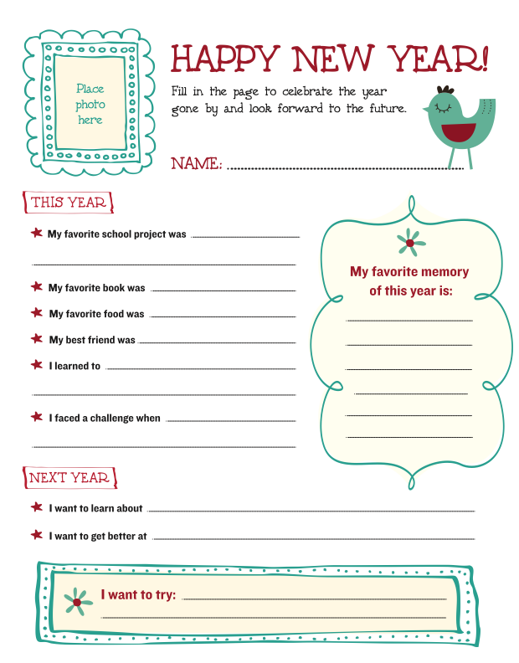

**January Activities**

**Page 8 of 8**

Sunday, January 3rd – Sunday Service with Holy Communion – 9am.

Tuesday, January 12 – Council Meeting – 7pm.

Sunday, January 17th – Sunday Service with Holy Communion – 9am.

Sunday, January 31st – Healing Service – 9am.

Annual Meeting after service - TBD

## Scripture Readings for January

**Sunday, January 3 Sunday, January 10**

**Second Sunday After Christmas The Baptism of Christ**

Jer 31: 7-14 or Sirach 24: 1-12 Gen 1: 1-5

Ps 147: 12-20 or Wisd of Sol 10: 15-21 Ps 29

Eph 1: 3-14 Acts 19: 1-7

Jn 1: (1-(), 10-18 Mk 1: 4-11

**Another Road**  **Defining Moments**

**Sunday, January 17 Sunday, January 24**

**Second Sunday After Epiphany Third Sunday After Epiphany**

1 Sam 3: 1-10, (11-20) Jon 3: 1-5, 10

Ps 139: 1-6, 13-18 Ps 62: 5-12

1 Cor 6: 12-20 1 Cor 7: 29-31

Jn 1: 43-51 Mk 1: 14-20

**Known and Loved**  **Follow Me**

**Sunday, January 31**

**Fourth Sunday After Epiphany**

Deut. 18: 15-20

Ps 111

1 Cor 8: 1-13

Mk 1: 21-28

**Power to Do**

**St. James United Church of Christ**

**9008 Meisner Road**

**Casco, MI 48064**

**Phone:**

(586) 727--1623

**Fax:**

(586) 27-0833

**E-mail:**

kgadd@ourstjameschurch.org



JANUARY

nEWSLETTER

