##### 9008 Meisner Road, Casco, MI 48064 / [www.ourstjameschurch.org/](http://www.ourstjameschurch.org/)

Newsletter

December 2020

Volume 5, Issue 11

Contents

News from Pastor Ken 1

Pastor Ken News Cont. 2

Prayers Needed 3

Outreach Ministry 3

Birthday 4

Anniversary 4

Spiritual Ministry 4

Worship Ministry 4

Discretionary Fund 4

Earthly Gift Ministry 4

Merry Christmas 5

Christmas Tote Bags 6

Ministers Needed 6

Bottle Can Collection 6

Military Prayer List 6

Kid’s Page 7

Activities 8

Scripture Readings 8



Greetings to all! Merry Christmas and a belated New Year!

I realize that it sounds odd hearing these well wishes in this order but that is how it goes in the church world. According to the Liturgical calendar the church New Year officially began the last Sunday in November this year with the first Sunday in Advent. For all of you keeping score this begins Liturgical year B.

Maybe more this year than previous years with all that has gone on and with a continued air of uncertainty, I continue to appreciate Advent more with every passing year. When I think of what Advent is all about, it is helpful for us to consider that Advent is to Christmas what Lent is to Easter. It is a time of spiritual preparation and discernment. It is that time when we can consider this incredible gift that we are about to receive and how we would like to use it. I like to think of the gift of Christmas as an unlimited gift card that we can use anytime and anyplace to shape and guide our lives. But like all gift cards, it only benefits us if we choose to use them.

I think my Christmas’ have become richer and more fulfilling as my Advent practices become richer and more intentional. I use Advent as a time of spiritual centering, reflection, and preparation for the year to come so when Christmas gets here, I am really ready. Not necessarily on the outside but on the inside. I think part of what use to (and still can) make me crazy about Christmas is that I thought everything needed to be perfect on the outside in order to be right on the inside, including gifts, decorating the house, the tree, the lights, the dishes, the…the…, the…. You see, I can make myself anxious just thinking about it. And while potentially becoming overwhelmed about the outside, it becomes easier to forget to prepare and make ready the inside. The heart and the spirit of Christmas.



https://www.facebook.com/St-James-United-Church-of-Christ-10150090210425008/

# News from Pastor Ken

The purpose of a newsletter is to provide specialized information to a targeted audience. A school newsletter can be a great way to develop a strong relationship with parents.

First choose a short title for your newsletter— something like "School News," or “Back to School.” As you choose the title, also take time to think about the newsletter’s theme. What important messages do you want to send parents and families?

Next, establish how much time and money you can spend on your newsletter. These factors will help determine how frequently you publish the newsletter and its length.

Use the body of your school newsletter to keep parents apprised of major assignments and class events, as well as any of school district news. Also share news for specific grade levels, and tell parents about upcoming events, new faculty, and school policies.

## Dear Parents

St. James United Church of Christ

So for years it is first things first. Heart and spirit first and then allow some time to put up a little tree, a few decorations, and a little bit of shopping. Just as a note, I do not buy things people will not use just because I do not know what they need. Ah…. Christmas

So once again I am gathering my meditation materials and have been making my short list of specific things I am seeking God’s direction about in my life. It is important for me to use this as a time and season of reflection and preparation. If you would like to join me in spirit for a day in prayer, meditation, or whatever practice you use to center your spirit, I would enjoy sharing that with you. I continue to be excited about the journey ahead. This year I invite you to join me in re-arranging prioritizes and sharing with me ways to more fully enjoy Advent and therefore Christmas.

First, slow down and take time to remember what this season is truly about. It is time for thinking about our individual relationships with God and listening for what it is God would have us to do and who it is that God would have us to be. It is a time of prayer, contemplation and discerning. It is a time for considering and acting on how it is you want God to impact your life. I want to remind you to expect the unexpected.

Secondly, Advent is the beginning of the new church year. It is a season for appreciating what is, together with the hope of what is to come. I look with anticipation toward this New Year both in my personal life as well as our life together and as a community of faith. This has been an interesting year of growth and transition for me and our church family. As we make our way through this year there is cause for a cautiously exciting sense of energy and anticipation. I invite you to pray and prepare for what God is calling you individually and we as a community, to be and to do in the year ahead.

Third, Advent is the gateway to Christmas and all the joy and anticipation that comes with it. As I stated earlier, I am aware that even in “normal times” during the holidays we are sometimes consumed with trying to do life perfectly. It seems that no matter how much we do or how hard we work there will always be a couple things more we could have done. Is not that the way life is. I think the key to happiness during the holidays as well as throughout life is to slow down, plan for what you can plan, do what you can do, and then relax and take time to enjoy the ride, knowing that things are always going to turn out a little differently than the plan. Make sure to leave room for the Spirit to do its thing.

During this time of Advent, I invite you to follow that simple formula, plan a little, do a little, and enjoy, remembering that the biggest gift that you will receive is not under the tree. It is the gift of God’s unending love for you, the gift of boundless, unconditional, unearned, mercy, grace, and forgiveness. So sit a moment, wait a while, take a deep breath, expect the unexpected and then prepare to open the Gift that can transform your life forever. Expect a miracle.

Remember that whoever you are and wherever you are on life’s journey, you are held in God’s unconditional love, boundless mercy, and unending grace. And there is a place for you here.

May you know the love and grace of God in your life. May your heart and life be filled with the Spirit. Merry Christmas!!

Take care and be well, Peace

Ken

**\*\*Live streaming of Sunday Services will continue at 9:00am on the St. James Facebook page\*\***

**Live streaming of Sunday Services will continue at 11am. from St. John’s Facebook page.**

**Pastor Ken Newsletter Continued**

**Page 2 of 8**



Maraleen

Sharon

Linda

Wayne I.

Carole

Karleen

Karen

Barb

Carolyn

Dave P.

George

Claudette

Wayne B.

Shirley

Dan K.

Keith

Sue

Toni

Karen

**Prayer List ….**

**Page 3 of 8**

**Outreach Ministry**

Helping Hands

**Current Needs:** Peanut butter, jelly & jams (preferably in plastic containers), tuna fish, boxed meals

Cereal.

**No expired or opened boxes of food accepted**

Clothing items for children from newborn to high school.

Not accepting books and furniture at this time.

.

**Blue Water Area Rescue Mission** **– B-WARM**

**B-WARM NEEDS**

**Both Men and Women houses:**

**Cleaning supplies:** Laundry soap, comet, type cleanser, general cleaning supplies, canned veggies and tomato sauces.

**Paper Supplies:** Napkins, toilet paper and Kleenex, trash bags small & large

**\*\*\***Looking for someone to work nights at the women’s facility if anyone knows anyone, call 810-956-0768 for details.

**Kids in Distress**

**Current needs** are as follows:

Hygiene items such as toothpaste, toothbrushes, soap, shampoo, body washes.

Boys and girls pants sizes 3-16, boys shirts size 14 -16, Girls size 5 long sleeve shirts, socks and underwear girls and boys sizes 2T to adult

|  |
| --- |
| 1 - Mark Beattie |
| 3 – Jerry Maedel |
| 6 - Kim LaDuke |
| 9 - Rusty Stover |
| 9 - Sierra Nicole Pauley |
| 10 - Teri Lynn Ross |
| 11 - Ashley Beattie |
| 13 - Frank Tringali |
| 19 - Shirley Teltow |
| 25 - Jeff Bandlow |
| 25 - Ken Gadd |
| 27 – Jim Robertson |
| 28 - Jeff LaDuke |
| 28 - Robin Meldrum |

|  |
| --- |
| 12 - Kelly & Terry Pauley |
| 16 - Kris and Wally Dombrowski |

**Page 4 of 8**

**Anniversaries in December**

## Happy Birthdays in December

**Spiritual Ministry**

Sunday School is now in session. Please feel free to bring your children to church and partake in the weekly Sunday School classes.

Please contact Sue Tews if you are interested in helping with Sunday school.

**Earthly Gifts**

Our donation goal for November was $5,852.00 of which $3,170.00 had been received as of Sunday, November 22nd to count with your other donations for November.

Our donation goal for December is $5,852.00. Please do what you can to help to meet St. James obligations.  If you cannot attend service you may still donate by mail to the church or mail to my home Ralph Ski, 8326 Meisner, Casco, MI 48064.  Mail is checked daily at both to keep items out of the weather and safe.

Thanks for your participation.

Ralph

**The Discretionary Fund**

**December 6, 2020**

Did you know this fund is utilized to aid with rent, utilities, medical supplies, food and transportation to doctors, etc.?

This is generated from the loose change collected the first Sunday of each month. Please empty your pockets and change purses that day to meet the needs of our church and community.

**Page 5 of 8**

Merry Christmas



**Page 6 of 8**

**Christmas Tote Bags for**

**Local Community Charities**

The items accepted anytime: hats, gloves/mittens, scarves, TOYS, hygiene items such as: toothpaste, washcloths, headbands, barrettes and bows, and school supplies.

We collect the below items for boys and girls from the age of 2 to 14 years old. Our goal is to **fill 100 tote bags for next Christmas 2021** without running out of items**.**

We were able to stuff 109 Christmas Tote Bags this year. Thank you to all contributed and assisted with set up and stuffing of the tote bags. Thank you Mark and Sue Tews for delivering all the bags.

**Ministry Needing Helpers!!!!!**

Members are needed to take the items received for donation to B-Warm, Kids-In-Distress and Helping Hands in Marine City, MI. As you see the boxes/tubs getting full please feel free to help in this ministry by taking the items to the designated places. **Call first**, to make sure they are open for deliveries.

B-Warm Kids-In-Distress Helping Hands

Bev & Gordie Kulman 310 s. Parker St.

1920 24th St 1114 S 7th St Marine City, MI 48039

Port Huron, MI 48060 St. Clair, MI 48079 (810) 765-3848

[(810) 956-0768](https://www.google.com/search?q=blue+water+area+rescue+mission+port+huron+mi&rlz=1C1CHBD_enUS725US725&oq=blue+water+area+rescue+mission&aqs=chrome.1.69i57j0.24248j0j7&sourceid=chrome&ie=UTF-8) [(810) 326-4505](https://www.google.com/search?rlz=1C1CHBD_enUS725US725&ei=j-5pW5X5EJCwsAW8gi4&q=kids+in+distress&oq=kids+in+distress&gs_l=psy-ab.3..0l2.106654.110108.0.110732.16.10.0.6.6.0.127.1111.1j9.10.0....0...1c.1.64.psy-ab..0.16.1140...0i131k1j0i67k1.0.DlX_ayFsvYg)



**Military Prayer List**

I will be including a list in the newsletter of our men and women in the military, to acknowledge those who serve and to pray for their safety. Please submit your love one’s, family member or friend’s name, rank and branch of service to Roberta Fisher to be placed on the list.

PFC Shane David Kinney Army Airborne

**Bottle / Can Collection**

We are collecting empty and clean bottles and cans with a deposit on them to support our Christian Education Program. Please bring them to church, there is a box in the basement, back room, by the door for them.

**Page 7 of 8**

**Kid’s Page**

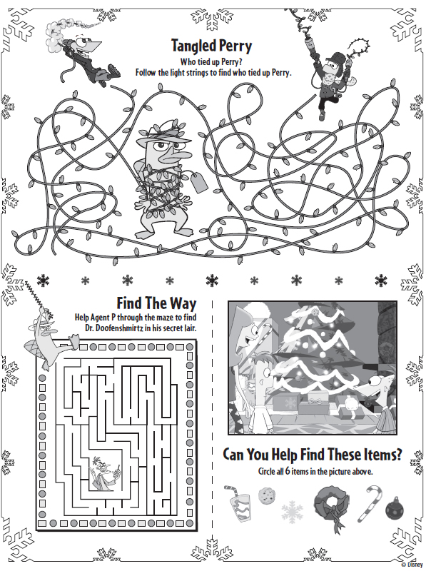

**December Activities**

**Page 8 of 8**

Sunday, December 6 – 9am - Sunday Service with Holy Communion

Tuesday, December 8 – 7pm - Council Meeting

Thursday, December 10 – 6:30pm – Women’s Christmas Party

Secret Pal Reveal (Short Program)

Sunday, December 20 – 9am Sunday Service with Holy Communion

Monday, December 21 – 7pm – Blue Christmas Service

Thursday, December 24 – 4pm – Christmas Service WITH Holy Communion at St. John’s

Christmas Service with Holy Communion at St. James – 7pm (11pm service at 7pm)

## Scripture Readings for December

**Sunday, December 6 Sunday, December 13**

**Second Sunday of Advent Third Sunday of Advent**

Isa 40: 1-11 Isa 61: 1-4, 8-11

Ps 85: 1-2, 8-13 Ps 126 or Luke 1; 46b-55

2 Peter 3: 8-15a 1 Thess 5: 16-24

Mk 1; 1-8 Jn 1: 6-8, 19-28

**Messengers of Christ**  **Shouts of Joy**

**Sunday, December 20 Sunday, December 27**

**Fourth Sunday of Advent First Sunday After Christmas**

2 Sam 7: 1-11, 16 Isa 61: 10-63:3

Luke 1: 46b-55 or Ps 89: 1-4, 19-26 Ps 148

Rom 16: 25-27 Gal 4: 4-7

Luke 1: 26-38 Luke 2; 22-40

**Birthing a Promise**  **Long-Awaited Gift**

**St. James United Church of Christ**

**9008 Meisner Road**

**Casco, MI 48064**

**Phone:**

(586) 727--1623

**Fax:**

(586) 27-0833

**E-mail:**

kgadd@ourstjameschurch.org



DECEMBER

nEWSLETTER

