##### 9008 Meisner Road, Casco, MI 48064 / [www.ourstjameschurch.org/](http://www.ourstjameschurch.org/)

Newsletter

November 2020

Volume 5, Issue 10

Contents

News from Pastor Ken 1

Pastor Ken News Cont. 2

Prayers Needed 3

Outreach Ministry 3

Birthday 4

Anniversary 4

Spiritual Ministry 4

Worship Ministry 4

Discretionary Fund 4

Earthly Gift Ministry 4

Worship Ministry 4

Thanksgiving Blessing 5

Christmas Tote Bags 6

Ministers Needed 6

Bottle Can Collection 6

Military Prayer List 6

Kid’s Page 7

Activities 8

Scripture Readings 9

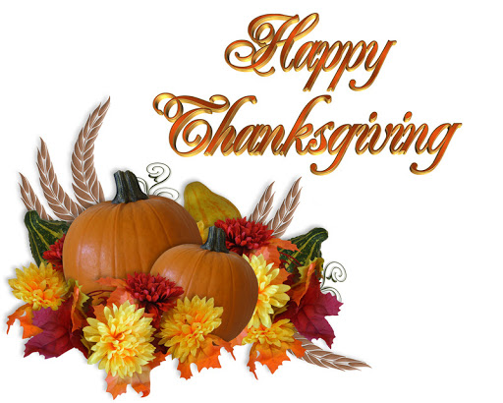

For many years now, November has been a spiritually significant month for me. There are many events and church remembrances that fill me with a sense of gratitude and an appreciation for God’s grace in my life. I have often said, “I have not gotten all that I deserve…. And for that I am grateful”.

The month always begins with All Saints Day, a day that allows me to remember and honor all those on whose shoulders I stand, both past and present. There have been so many people that have touched my life in so many wonderful ways. I truly enjoy thinking about them while on my journey, knowing they travel with me fills me with grace and humility.

About grace, this is the month that causes me to be intentionally focused on gratitude. As always, I quote my old friend Dwight who used to regularly remind me that “gratitude is the aristocrat of attitudes”. I could not agree more. Gratitude for me is where joy and contentment are found. He would also regularly remind me that I could not get what I wanted until I wanted what I got. I don’t necessary think that was about wanting lives hardships or the possibility of the future accumulation of “stuff” so much as a reminder that happiness and contentment are found inside rather than outside of us. And once we wanted what we had (gratitude) we would not find it so necessary to have the “stuff”.

And then there is Thanksgiving. Thanksgiving is one of my favorite holidays. Perhaps it is because the marketing world and big box stores have not figured out how to make a ton of money on it yet. Even though it makes me crazy that some stores want to be open Thanksgiving night to take peoples Christmas money. I am even happier that some stores who tried it the last couple years have decided to stay closed this year.

In these challenging times, it can seem difficult at times to find things to be grateful for. Therefore, here is my annual invitation for you to participate in one of my more meaningful Thanksgiving practices.



https://www.facebook.com/St-James-United-Church-of-Christ-10150090210425008/

# News from Pastor Ken

The purpose of a newsletter is to provide specialized information to a targeted audience. A school newsletter can be a great way to develop a strong relationship with parents.

First choose a short title for your newsletter— something like "School News," or “Back to School.” As you choose the title, also take time to think about the newsletter’s theme. What important messages do you want to send parents and families?

Next, establish how much time and money you can spend on your newsletter. These factors will help determine how frequently you publish the newsletter and its length.

Use the body of your school newsletter to keep parents apprised of major assignments and class events, as well as any of school district news. Also share news for specific grade levels, and tell parents about upcoming events, new faculty, and school policies.

## Dear Parents

St. James United Church of Christ

Every year, sometime around Thanksgiving I write a list of 4-6 things that I am TRULY grateful for (I’m not talking about grateful for chocolate ice cream grateful, though I am, but what I am TRULY grateful for). As a side note, if you can only think of one or two- think harder, if you want to write 20-30, then think harder and prioritize the top 4-6. Then I put the list somewhere I can see it regularly, on the refrigerator, near the computer monitor, bathroom mirror, you get the idea, as a reminder. Sometimes when life gets challenging, it can be easy to forget. It is helpful for me to have a little written reminder of God’s many blessings in my life.

If you are one who finds themselves bubbling over with gratitude, or at least have some sense of it. I encourage you to lend a hand, write a note, make a call or drop an email to someone who you know who could use a little reminder (by the way, that’s just about everybody) that one of lives blessings is that we have people in our life that simply care. Sometimes it is the smallest gestures that make the biggest difference.

I am also looking forward to my Advent time of reflection and preparation. It begins the last Sunday in November this year. I invite you to participate with me in some small way. It is about a daily reminder of my relationship with God. Truly a time of prayer and meditation. I invite you to join me in remembering that despite what the major retailers would have us believe, Advent is not Christmas. It is a time of intentional and internal preparation for the spiritual gifts of Christmas. More on this next month.

You have touched my life in significant ways and I give thanks daily for you. I wish you a Thanksgiving Season filled with grace and gratitude that lasts throughout the year. Remember that whoever you are and wherever you are on life’s journey, you are held in God’s unconditional love, boundless mercy, unending grace and that there is a place for you here.

Take care and be well, Peace

Ken

And I thought you might find this interesting…. **Definitions of Gratitude**

**Webster:** Synonyms and Antonyms of GRATITUDE

acknowledgment of having received something good from another <accept these flowers as a token of my *gratitude*>

**Synonyms** [appreciation](http://www.merriam-webster.com/dictionary/appreciation), [appreciativeness](http://www.merriam-webster.com/dictionary/appreciativeness), [gratefulness](http://www.merriam-webster.com/dictionary/gratefulness), [gratitude](http://www.merriam-webster.com/dictionary/gratitude), [thankfulness](http://www.merriam-webster.com/dictionary/thankfulness)

**Related Words:** [thanksgiving](http://www.merriam-webster.com/dictionary/thanksgiving); [gratification](http://www.merriam-webster.com/dictionary/gratification), [indebtedness](http://www.merriam-webster.com/dictionary/indebtedness), [satisfaction](http://www.merriam-webster.com/dictionary/satisfaction); [acknowledgment](http://www.merriam-webster.com/dictionary/acknowledgment) (*or*acknowledgement), [recognition](http://www.merriam-webster.com/dictionary/recognition), [tribute](http://www.merriam-webster.com/dictionary/tribute)

**Christian Bible:** Thankfulness, Thanksgiving

**Gratitude in Islam**

Gratitude in Islam is one of the most fundamental aspects of this religion. A Muslim is not merely one cognizant of the fact that the creator of the universe is one and is responsible for everything he has in this life i.e. his consciousness, his health, his family, his sanity and his wealth but also realizes that it is his obligation to express gratitude to his lord.

**Gratitude in Judaism**

The Hebrew term for gratitude literally means “recognizing the good”. Practicing gratitude recognizes the good that is already yours.

**\*\*Live streaming of Sunday Services will continue at 9:00am on the St. James Facebook page\*\***

**Live streaming of Sunday Services will continue at 11am. from St. John’s Facebook page.**

**Pastor Ken Newsletter Continued**

**Page 2 of 9**

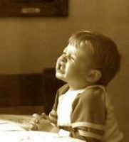

Maraleen

Sharon

Linda

Wayne I.

Carole

Karleen

Karen

Barb

Carolyn

George

Claudette

Wayne B.

Shirley

Dan K.

Keith

Sue

Toni

Karen

**Prayer List ….**

**Page 3 of 9**

**Outreach Ministry**

Helping Hands

**Current Needs:** Peanut butter, jelly & jams (preferably in plastic containers), tuna fish, boxed meals

Cereal.

**No expired or opened boxes of food accepted**

Clothing items for children from newborn to high school.

Not accepting books and furniture at this time.

.

**Blue Water Area Rescue Mission** **– B-WARM**

**B-WARM NEEDS**

**Both Men and Women houses:**

**Cleaning supplies:** Laundry soap, comet, type cleanser, general cleaning supplies, canned veggies and tomato sauces.

**Paper Supplies:** Napkins, toilet paper and Kleenex, trash bags small & large

**\*\*\***Looking for someone to work nights at the women’s facility if anyone knows anyone, call 810-956-0768 for details.

**Kids in Distress**

**Current needs** are as follows:

Hygiene items such as toothpaste, toothbrushes, soap, shampoo, body washes.

Boys and girls pants sizes 3-16, boys shirts size 14 -16, Girls size 5 long sleeve shirts, socks and underwear girls and boys sizes 2T to adult

|  |
| --- |
| 1 - LeAnne Bandlow |
| 4 - Gary Teltow |
| 8 - Joel Szymanski |
| 8 - Sharon Fritz |
| 9 - John Lyszczyk |
| 13 - Julie Wendt |
| 15 - Matt LaDuke |
| 15 - Dan Riley |
| 20 - Jennifer Uppleger |
| 23 - Lee Mahnke |

**Spiritual Ministry**

Sunday School is now in session. Please feel free to bring your children to church and partake in the weekly Sunday School classes.

Please contact Sue Tews if you are interested in helping with Sunday school.

## Happy Birthdays in November

**Page 4 of 9**

**Earthly Gifts**

The goal for November is $5852.00.  Thank you for your endeavors to keep St. James in a position to keep us close to financial obligations.

Donations can be mailed or delivered to Ralph our Treasurer at 8326 Meisner, Casco, MI 48064 or mailed to St. James UCC, 9008 Meisner, Casco, MI 48064. Mailboxes are checked daily.

Giving can also be done through St. James website’s “Giving” page. Giving through the St. James website can be done via a Debit/Credit card or Paypal.

Thanking everyone for their contributions  to help make St. James solvent.

**The Discretionary Fund**

**November 1, 2020**

Did you know this fund is utilized to aid with rent, utilities, medical supplies, food and transportation to doctors, etc.?

This is generated from the loose change collected the first Sunday of each month. Please empty your pockets and change purses that day to meet the needs of our church and community.

Thanksgiving Blessing

**Page 5 of 9**



**Page 6 of 9**

**Christmas Tote Bags for**

**Local Community Charities**

**November 2020 collection, please see list of items still needed in church basement.** The items accepted anytime: hats, gloves/mittens, scarves, TOYS, hygiene items such as: toothpaste, washcloths, headbands, barrettes and bows, and school supplies.

We collect the below items for boys and girls from the age of 2 to 14 years old. Our goal is to **fill 100 tote bags on November 15, 2020** without running out of items**. I will need assistance in setting up for stuffing of the tote bags on Saturday, November 14, 2020 at 11:00pm.**

**Ministry Needing Helpers!!!!!**

Members are needed to take the items received for donation to B-Warm, Kids-In-Distress and Helping Hands in Marine City, MI. As you see the boxes/tubs getting full please feel free to help in this ministry by taking the items to the designated places. **Call first**, to make sure they are open for deliveries.

B-Warm Kids-In-Distress Helping Hands

Bev & Gordie Kulman 310 s. Parker St.

1920 24th St 1114 S 7th St Marine City, MI 48039

Port Huron, MI 48060 St. Clair, MI 48079 (810) 765-3848

[(810) 956-0768](https://www.google.com/search?q=blue+water+area+rescue+mission+port+huron+mi&rlz=1C1CHBD_enUS725US725&oq=blue+water+area+rescue+mission&aqs=chrome.1.69i57j0.24248j0j7&sourceid=chrome&ie=UTF-8) [(810) 326-4505](https://www.google.com/search?rlz=1C1CHBD_enUS725US725&ei=j-5pW5X5EJCwsAW8gi4&q=kids+in+distress&oq=kids+in+distress&gs_l=psy-ab.3..0l2.106654.110108.0.110732.16.10.0.6.6.0.127.1111.1j9.10.0....0...1c.1.64.psy-ab..0.16.1140...0i131k1j0i67k1.0.DlX_ayFsvYg)



**Military Prayer List**

I will be including a list in the newsletter of our men and women in the military, to acknowledge those who serve and to pray for their safety. Please submit your love one’s, family member or friend’s name, rank and branch of service to Roberta Fisher to be placed on the list.

PFC Shane David Kinney Army Airborne

**Bottle / Can Collection**

We are collecting empty and clean bottles and cans with a deposit on them to support our Christian Education Program. Please bring them to church, there is a box in the basement, back room, by the door for them.

**Kid’s Page**

**Page 7 of 9**

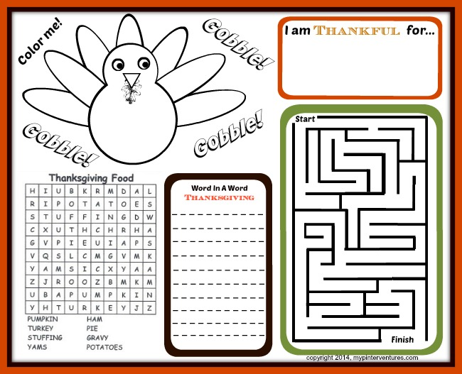

**November Activities**

**Page 8 of 9**

Tuesday, November 10 – 7pm – Council Meeting

Saturday, November 14 – 11am – Sort Tote Bags Items

Sunday, November 15 – 9am – Sunday Service with Holy Communion

Fill Tote Bags after coffee hour

Sunday, November 22 – Greening of the Church - After coffee hour

Sunday, November 29 – 9am – Healing Service

**December Activities**

Sunday, December 6 – 9am - Sunday Service with Holy Communion

Tuesday, December 8 – 7pm - Council Meeting

Thursday, December 10 – 6:30pm – Women’s Christmas Party

Secret Pal Reveal (Short Program)

Sunday, December 20 – 9am Sunday Service with Holy Communion

Monday, December 21 – 7pm – Blue Christmas Service

Thursday, December 24 – 4pm – Christmas Service at St. John’s

Christmas Service at St. James – Times to be determined

**Page 9 of 9**

**Sunday, November 1 Sunday, November 8**

**Twenty-Second Sunday after Pentecost Twenty-Third Sunday after Pentecost**

Josh 3 : 7-17 and Ps 107 : 1-7, 33-37 Josh 24: 1-3a, 14-25, and PS 78: 1-7

Mic 3: 5-12 and Ps 43 Wisd of Sol 6: 12-16 or Amos 5: 18-24 Isa 25: 1-9 and Ps 23 and Wisd of Sol 6: 17-20 or Ps 70

1 Thess 2: 9-13 1 Thess 4: 13-18

Matt 23: 1-12 Matt 25: 1-13

**Partners in Service**  **Tending God’s Light**

**Sunday, November 15 Sunday, November 22**

**Tweny-Fourth Sunday after Pentecost Reign of Christ**

Judg 4: 1-7 and Ps 123 Ezek 34: 11-16, 20-24, Ps 100

Zeph 1: 7, 12-18 and Ps 90: 1-8, (9-11), 12 Ezek 34: 11-16, 20-24 and Ps 95: 1-7a

1Thess 5: 1-11 Eph 1: 15-23

Matt 25: 14-30 Matt 25: 31-46

**Extravagant Opportunity**  **Reigning Compassion**

**Sunday, November 29**

**First Sunday of Advent**

Isa 64:1-9

Ps 80: 1-7, 17-19

1 Cor 1: 3-9

Mk 13: 24-37

**Where Are You, God?**

## Scripture Readings for November

**St. James United Church of Christ**

**9008 Meisner Road**

**Casco, MI 48064**

**Phone:**

(586) 727--1623

**Fax:**

(586) 27-0833

**E-mail:**

kgadd@ourstjameschurch.org

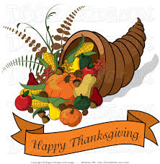

NOVEMBER

nEWSLETTER

