##### 9008 Meisner Road, Casco, MI 48064 / [www.ourstjameschurch.org/](http://www.ourstjameschurch.org/)

Newsletter

October 2020

Volume 5, Issue 9

Contents

News from Pastor Ken 1

Pastor Ken News Cont. 2

Prayers Needed 3

Outreach Ministry 3

Birthday 4

Anniversary 4

Spiritual Ministry 4

Worship Ministry 4

Discretionary Fund 4

Earthly Gift Ministry 4

Worship Ministry 4

Fall Reading 5

Christmas Tote Bags 6

Ministers Needed 6

Bottle Can Collection 6

Military Prayer List 6

Kid’s Page 7

Scripture Readings 8



As we enjoy the last few days of summer weather, I must say that I very much enjoy the season of fall for so many wonderful reasons.

First, I love fall weather. It’s perfect ….warm sunny days and cool gentle nights. I enjoy the change in temperature but even more the anticipation and realization of the incredible palette of color that surrounds us in trees, bushes, fall flowers and vegetables. Even fall sunrises and sunsets seem more glorious. The colors are beautiful, the air is crisp, and it is perfect window open while sleeping with a blanket weather. Even my nutty dogs seem to relish in the cool air and piles of leaves to roll and play in.

Just like the weather, it has been a season of anticipation and change for many of us. Even though I know what season follows fall, I have come to accept that this is the natural order of things. What's more, I know that before long, the cycle will be complete and with certainty, spring will return. Until then, I enjoy the seasons as they come, each with its own unique challenges, joys and beauty. With the weather just like life, I have found the key to peace and serenity is “Accepting life on life’s terms”. So take heart, keep the faith, enjoy and continue to be part of the great transformation. With everything going on in the world today that same perspective applies to so much more than just the weather.

And of course the season has me thinking about my gardens. Fall gives me a great appreciation for gardening and gardeners, and the joy of being a steward of God’s creation. The older I get the more I realize it is the simple things in life that make me happiest… ah life is good.



https://www.facebook.com/St-James-United-Church-of-Christ-10150090210425008/

# News from Pastor Ken

The purpose of a newsletter is to provide specialized information to a targeted audience. A school newsletter can be a great way to develop a strong relationship with parents.

First choose a short title for your newsletter— something like "School News," or “Back to School.” As you choose the title, also take time to think about the newsletter’s theme. What important messages do you want to send parents and families?

Next, establish how much time and money you can spend on your newsletter. These factors will help determine how frequently you publish the newsletter and its length.

Use the body of your school newsletter to keep parents apprised of major assignments and class events, as well as any of school district news. Also share news for specific grade levels, and tell parents about upcoming events, new faculty, and school policies.

## Dear Parents

St. James United Church of Christ

When I think of my own gardening experience, I can compare it to how our spiritual journey works as well. Some seem to be born into it while others of us go kicking and screaming. Then sometimes quickly, sometimes slowing we find ourselves moving from resistance to tolerance to embracing and enjoying it and often without even noticing, a spiritual transformation occurs. The only thing required was the willingness to participate and to be open to the possibility of change.

As always, while in the garden I remember, ever so humbly, the many gifts that have been given to me. During this harvest time I am reminded of God's grace and abundance in my life and the importance of sharing that abundance with others. Just like those roadside stands offering various “extra” vegetables for free. Even freely sharing the story of our own journey can have a profound effect on others.

I encourage you to share your journey with others that they too may experience the joy and hope of transformation and perhaps encourage them to take the first steps into their own spiritual garden. It is exciting to be a part of this faith communities garden of growth and harvest. We invite you to sense your ministry, feel your call and join us in this journey together, each according to our gifts, talents and energy.

In the garden at home and here in our church’s spiritual garden there is always plenty to do and each helping hand regardless of how large or small makes life a little easier for everyone. Any gardener will tell you how much better things look and taste when we have taken part in their creation. Whatever your gift and ability, regardless of how significant, or insignificant, you may think it is, know that we are all richer because you are here sharing those gifts. Whatever we do, we do in the light of God’s unconditional love, boundless mercy and unending grace.

We look forward to growing together and invite you to join us on the journey and harvest. Whoever you are and wherever you are on life's path, there is a place for you here and we welcome you.

One more thing. I have been sharing this little prayer I acquired along the way. Seems appropriate for fall.

Dear God, thank you

for all that you have given me

for all that you have taken from me

for all that you have left me

Amen

Take care and be well, Peace

Ken

**\*\*Live streaming of Sunday Services will continue at 9:00am on the St. James Facebook page\*\***

**Live streaming of Sunday Services will continue at 11am. from St. John’s Facebook page.**

**Pastor Ken Newsletter Continued**

**Page 2 of 8**



George

Claudette

Wayne B.

Shirley

Russ

Dan K.

Keith

Sue

Toni

Karen

Janett

Maraleen

Sharon

Linda

Andy

Wayne I.

Carole

Karleen

Karen

Barb

Don

**Prayer List ….**

**Page 3 of 8**

**Outreach Ministry**

**Blue Water Area Rescue Mission** **– B-WARM**

Helping Hands

**Current Needs:** Peanut butter, jelly & jams (preferably in plastic containers), tuna fish, boxed meals

Cereal. Clothing items for children from newborn to high school.

**No expired or opened boxes of food accepted**.

**B-WARM NEEDS**

**Both Men and Women houses:**

**Cleaning supplies:** Laundry soap, comet, type cleanser, general cleaning supplies, canned veggies and tomato sauces.

**Paper Supplies:** Napkins, toilet paper and Kleenex, trash bags small & large

**Current needs** are as follows:

Hygiene items such as toothpaste, toothbrushes, soap, shampoo, body washes.

Socks and underwear girls and boys sizes 2T to adult, winter shirts girls and boys size 3-18.

**Kids in Distress**

|  |
| --- |
| 9 - Robin & Glenn Meldrum |
| 14 - Lisa & Lee Mahnke |
| 14 - Sherri & Wayne Ingles |
| 30 - Joan & Bernard Teltow |

**Page 4 of 8**

The goal for October is $5852.00.  Thank you for your endeavors to keep St. James in a position to keep us close to financial obligations.

Donations can be mailed or delivered to Ralph our Treasurer at 8326 Meisner, Casco, MI 48064 or mailed to St. James UCC, 9008 Meisner, Casco, MI 48064. Mailboxes are checked daily.

Giving can also be done through St. James website’s “Giving” page. Giving through the St. James website can be done via a Debit/Credit card or Paypal.

Thanking everyone for their contributions  to help make St. James solvent.

**Earthly Gifts**

**Anniversaries in October**

## Happy Birthdays in October

|  |
| --- |
| 5 - Gerald Fritz |
| 6 - Mark Uppleger |
| 13 - Julie Wendt |
| 14 – Julie Robbins |
| 18 – Carol Rooks |
| 19 - Dave Pittman |
| 22 - Glenn Meldrum |
| 27 - Brianna Frances-Jean Pauley |
| 28 – Mary Smith |
| 30 – Bob Wagner |

**Spiritual Ministry**

Sunday School began Sunday, September 13, 2020. Please feel free to bring your children to church and partake in the weekly Sunday School classes.

Please contact Sue Tews if you are interested in helping with Sunday school.

**The Discretionary Fund**

**October 4, 2020**

Did you know this fund is utilized to aid with rent, utilities, medical supplies, food and transportation to doctors, etc.?

This is generated from the loose change collected the first Sunday of each month. Please empty your pockets and change purses that day to meet the needs of our church and community.

**Worship Ministry**

Looking for Liturgists, Communion Servers and Usher/Greeters during Holy Week. Let Robin Meldrum know if you are interested in any of these ministries.

Need help in the following ministries Communion Servers, Usher/Greeter, Liturgists and Altar Care. Sign-up sheets for each are provided in the basement.

Fall Poem

**Page 5 of 8**

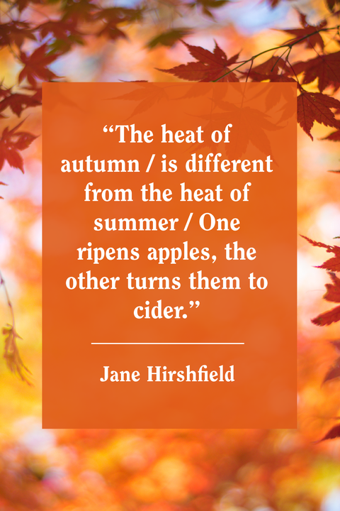

**Page 6 of 8**

**Christmas Tote Bags for**

**Local Community Charities**

**October 2020 collection is for hats, scarves, gloves/mittens and TOYS. We are in desperate needs of toys.**

The items accepted anytime: hygiene items such as: toothpaste, washcloths, headbands, barrettes and bows, and school supplies.

**We are also in the need of roping for the tote bags. We will be inserting the roping after church service on Sunday in October (after I acquire the roping we need), so please stay and help if you can.**

We collect the below items for boys and girls from the age of 2 to 14 years old. Our goal is to fill 100 tote bags on November 15, 2020 without running out of items**. I will need assistance in setting up for stuffing of the tote bags on Saturday, November 14, 2020 at 12:00pm.**

**Ministry Needing Helpers!!!!!**

Members are needed to take the items received for donation to B-Warm, Kids-In-Distress and Helping Hands in Marine City, MI. As you see the boxes/tubs getting full please feel free to help in this ministry by taking the items to the designated places. **Call first**, to make sure they are open for deliveries.

B-Warm Kids-In-Distress Helping Hands

Bev & Gordie Kulman 310 s. Parker St.

1920 24th St 1114 S 7th St Marine City, MI 48039

Port Huron, MI 48060 St. Clair, MI 48079 (810) 765-3848

[(810) 956-0768](https://www.google.com/search?q=blue+water+area+rescue+mission+port+huron+mi&rlz=1C1CHBD_enUS725US725&oq=blue+water+area+rescue+mission&aqs=chrome.1.69i57j0.24248j0j7&sourceid=chrome&ie=UTF-8) [(810) 326-4505](https://www.google.com/search?rlz=1C1CHBD_enUS725US725&ei=j-5pW5X5EJCwsAW8gi4&q=kids+in+distress&oq=kids+in+distress&gs_l=psy-ab.3..0l2.106654.110108.0.110732.16.10.0.6.6.0.127.1111.1j9.10.0....0...1c.1.64.psy-ab..0.16.1140...0i131k1j0i67k1.0.DlX_ayFsvYg)



**Military Prayer List**

I will be including a list in the newsletter of our men and women in the military, to acknowledge those who serve and to pray for their safety. Please submit your love one’s, family member or friend’s name, rank and branch of service to Roberta Fisher to be placed on the list.

PFC Shane David Kinney Army Airborne

**Bottle / Can Collection**

We are collecting empty and clean bottles and cans with a deposit on them to support our Christian Education Program. Please bring them to church, there is a box in the basement, back room, by the door for them.

**Kid’s Page**

**Page 7 of 8**

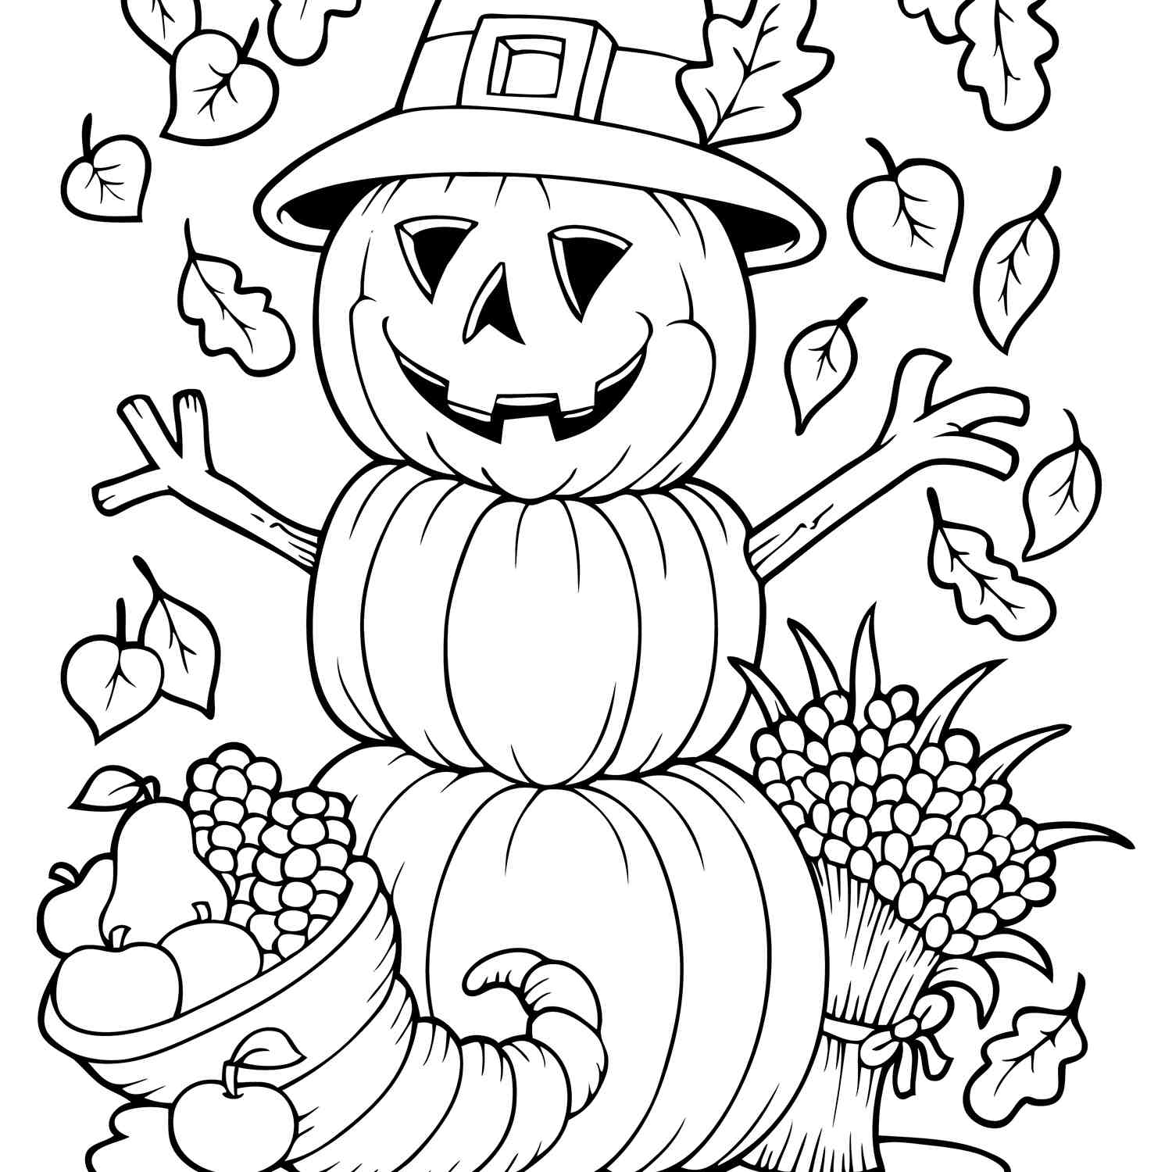

**Sunday, October 4 Sunday, October 11**

**Eighteenth Sunday of Pentecost Nineteenth Sunday after Pentecost**

Ex 20 ; 1-4, 7-9, 12-20 and Ps 19 Ex 32: 1-14 and Ps 106 : 19-23

Isa 5: 1-7 and Ps 80: 7-15 Isa 25: 1-9 and Ps 23

Phil 3: 4b-14 Phil 4: 1-9

Matt 21: 33-46 Matt 22: 1-14

**Wisdom for the Way**  **Praiseworthy Living**

**Sunday, October 18 Sunday, October 25**

**Twentieth Sunday after Pentecost Twenty-First Sunday after Pentecost**

Ex 33: 12-23 and Ps 99 Deut 34 : 1-12 and PS 90 : 1-6, 13-17

Isa 45: 1-7 and Ps 86: 1-9, (10-13) Lev 19: 1-2, 15-18 and Ps 1

1 Thess 1: 1-10 1 Thess 2: 1-8

Matt 22: 15-22 Matt 22: 34-46

**Living Messages**  **The Compassionate Life**

## Scripture Readings for October

**Page 8 of 8**

**St. James United Church of Christ**

**9008 Meisner Road**

**Casco, MI 48064**

**Phone:**

(586) 727--1623

**Fax:**

(586) 27-0833

**E-mail:**

kgadd@ourstjameschurch.org

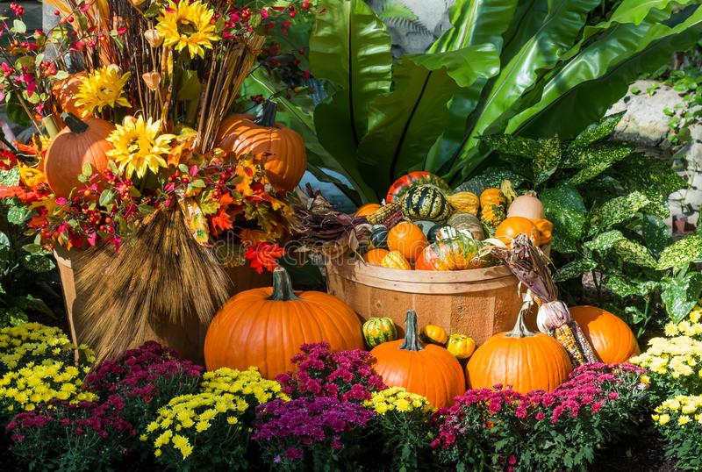

OCTOBER

nEWSLETTER

