##### 9008 Meisner Road, Casco, MI 48064 / [www.ourstjameschurch.org/](http://www.ourstjameschurch.org/)

Contents

News from Pastor Ken 1

Pastor Ken News Cont. 2

Upcoming Events 2

Discretionary Fund 2

Prayers Needed 3

Outreach Ministry 3

Birthday 4

Anniversaries 4

Worship Ministry 4

Spiritual Ministry 4

Earthly Gift Ministry 4

Military List 4

Bottle Can Collection 4

Roof Collection 4

Summer Poem 5

Christmas Tote Bags 6

Ministers Needed 6

Roof Collection 6

Bottle Can Collection 6

Kid’s Page 7

Altar Care 8

Communion Servers 8

Ushers/Greeters 8

Liturgist Readers 8

Scripture Readings 8



It must be summer. People are talking about weddings, family reunions, and fun on the water. To say nothing about the fact that the gardens are bursting, the birds are chirping, and everyone seems just a little happier. Must be the vitamin D.

I do so enjoy finally having morning prayers and meditation on the deck. With a couple cups of coffee or tea, of course.

Something about summer that somehow give us permission to take a deep breath, smell the roses or peonies or lilacs or… (literally and figuratively) and give our minds, bodies and spirits a moment to simply be. Slow down, plan a day trip, go to the beach, sit lazily under a tree and read, simply enjoy time with family and friends, or just be still for a moment

For me anyway, and maybe for you, the key is to not try to rush through the relaxation. Just be present and enjoy. You know that long list of things you need to get done this summer. I start the summer accepting the fact that the list of things I want to do is longer than the summer is. So, get done what you can but not at the expense of having some time for yourself.

Summer is supposed to be a time of regeneration, discovery, and transformation. The summer is full of exciting opportunities such as graduations, weddings and road trips. This can also be a challenging time for some for some of us some of us face issues of health, money and loss.

Life certainly can be full of interesting journeys. Know that whatever the summer holds for us, we lift each other up and keep each other in our hearts and in our prayers.

# News from Pastor Ken

https://www.facebook.com/St-James-United-Church-of-Christ-10150090210425008/



Newsletter

June 2019

Volume 4, Issue 6

The purpose of a newsletter is to provide specialized information to a targeted audience. A school newsletter can be a great way to develop a strong relationship with parents.

First choose a short title for your newsletter— something like "School News," or “Back to School.” As you choose the title, also take time to think about the newsletter’s theme. What important messages do you want to send parents and families?

Next, establish how much time and money you can spend on your newsletter. These factors will help determine how frequently you publish the newsletter and its length.

Use the body of your school newsletter to keep parents apprised of major assignments and class events, as well as any of school district news. Also share news for specific grade levels, and tell parents about upcoming events, new faculty, and school policies.

## Dear Parents

St. James United Church of Christ

## Upcoming Events

* June 2 – Communion Sunday 9am

Discretionary Fund

* June 5 – Discussion Group at St. John’s 7pm – Spiritual Journey
* June 11 – Council Meeting 7pm
* June 12 – Discussion Group at St. John’s 7pm – Spiritual Growth

June 16 – Communion Sunday – 9am - Father’s Day Coffee Hour

* June 19 – Discussion Group at St. John’s 7pm – Spiritual Growth
* June 23 – St. John’s & St. James, place TBD
* June 26 – Discussion Group at St. John’s 7pm – Spiritual Growth
* June 29 – Family Movie Night at St. James - Secondhand Lions 8pm
* June 30 – Healing Service

It always amazes me that even as the church year winds down, some of you are already busy planning and getting ready for the fall season here. So many of you are busy in selfless ministry. Please remember to take time to breathe and enjoy. This includes Music, Sunday School, outings, fun activities, euchre, meals, events, coffee hours, keeping the inside and outside of the property well cared for, bulletins and newsletters published, and on and on and on. Makes me want to rest just thinking about how hard you all work. A BIG thank you to all of you.

I am glad we can all take a well-deserved break and allow things to be just a little more casual. As we venture off for a time of reflection, vacations and summer fun, remember that wherever you are, God is there also. So when you have an opportunity, stop in other churches along the road and say “hello”. Wherever you are, God is always happy to see you. And when you are back in town, we look forward to seeing you.

Remember that regardless of where the summer takes you, you are held in God’s unconditional love, boundless mercy, and unending grace and there is a place for you here. Have a great first month of summer. I look forward to sharing the season with you.

Take care and be well, Peace

Ken

**Page 2 of 8**

**Pastor Ken Newsletter Continued**

**The Discretionary Fund**

**June 2, 2019**

Did you know this fund is utilized to aid with rent, utilities, medical supplies, food and transportation to doctors, etc.?

This is generated from the loose change collected the first Sunday of each month. Please empty your pockets and change purses that day to meet the needs of our church and community.

Karen Marie

Sue

Rich

Maraleen

Clark

Tony

Baby Charlee

Trudy

Amy

Sharon

Linda

Russell

**B-WARM NEEDS**

Cleaning supplies: Toilet bowl cleaner, bleach, laundry soap, dish washing detergent, bathroom cleansers.

Paper products: paper towels, napkins, toilet paper and kleenex

Men’s clothing: sweatshirts and jackets.

Hygiene Items: shaving cream, disposable razors, deodorants, shampoo

**Current needs** are as follows:

Clothes 3T, 4T, 5 & 7/8, Boys and girls Size 6 shirts, shorts & pants, socks, underwear, baby hygiene items, baby wipes, shampoo & conditioner, pots & pans, towels

To put in to perspective the impact KIDS has on the community, in 2018 they distributed… 4,611 baby outfits, 1,766 coats, 3,723 pairs of shoes, 9,605 socks, and underwear, 18,249 shirts and 14,417 pants.

KIDS also collect’s overly worn with holes or stains and sells them to a recycle company . We the money they raise it allows them to purchase items that are needed and helps keep the washer and dryers running to do laundry for the children they serve.

**Blue Water Area Rescue Mission** **– B-WARM**

St. Augustine Richmond Food Pantry

**Current Needs:** pancake mix, syrup, jams and jellies, and boxed potatoes

**Page 3 of 8**

George

David

Deborah

Lynn

Johnnie

Peggy

Joanne

Claudette

Lorene

Dorothy

Russ

Darrell

Tom

**Outreach Ministry**

**Kids in Distress**



**Prayer List ….**

|  |
| --- |
| 7 –Carole & Al Bryant |
| 7 – Sue & Mark Tews |
| 12 – Dave & Lynn Robertson |
| 25 – Teri & Bob Wagner |
| 28 – Art & Cheryl Wagner |
| 30 - Shirley & Fred Teltow |

Anniversaries in June

## Happy Birthdays in June

**Page 4 of 8**

The contribution goal for May was $5852.00.  Contributions including the funds from the euchre party amounted to $4304.00.  Many thanks to those who looked at their donation to St. James and were able to contribute a few extra dollars to help meet the needs of St. James.   Once again $5852.00 is our goal for June donations.  If you are going away to enjoy the summer,  please remember giving to keep St. James in mind.  There have been a few envelope requests that have been filled and placed in the envelope box near the church main entry but never have been picked up or used.  Please let me know if there is any problem with your request.

**Earthly Gifts**

|  |
| --- |
| 3 – Larry Bandlow |
| 5 – Doris Doss |
| 10 – Mike Lindke |
| 10 – Betty Robertson |
| 11 – Ian Riley |
| 14 – Dawn Kargula |
| 21 – Elise Lyszczyk |
| 24 - Joan Teltow |
| 24 - Bryce Bacheldor |
| 30 – Erin Riley |

**Worship Ministry**

Please consider signing up for the ministries of Usher/Greeter, Liturgists

and Altar Care. Sign-up sheets for each are provided in the basement.



**Military Prayer List**

I will be including a list in the newsletter of our men and women in the military, to acknowledge those who serve and to pray for their safety. Please submit your love one’s, family member or friend’s name, rank and branch of service to Roberta Fisher to be placed on the list.

PFC Shane David Kinney Army Airborne

**Spiritual Ministry**

Discussion Group to be held at St. John’s starting on Wednesday, June 5 at 7pm. For the next four Wednesdays, till June 26. The subject will be Spiritual Journey.

New member service will be held on Sunday, June 9 at 9am. Please see Pastor Ken if you would like to become a member of St. James UCC.

**Summer Poem**

**Page 5 of 8**



Weather gets warmer and fruits riper

Clothes replaced with the ones lighter

Sun in the sky blazing like a silver ball

Makes wheat and vegetables to be tall

Every morning breeze shakes the green trees

Brings us joy and the smell of fragrant leaves

Boiling springs in the heart of high mountains

Are welcoming the thirsty birds sitting in tens

Farmers' busy time on the fields gathering crops

Tired bodies sweating look like they stopped the clocks

Harvest season of juicy and watery fruits

Greatest reason refresh dry and thirsty throats

Children's laughter and playing shouts fill the air

Up and down, jumping and kicking with no care

Everyone does a job, men bring and chop the logs

Little children go after one another and play with bugs

**Christmas Tote Bags for**

**Local Community Charities**

**Page 6 of 8**

We collect the below items for boys and girls from the age of 2 to 14 years old. Our goal is to fill 100 tote bags by November 11, 2019 without running out of items**. June 2019 collection is for toys for ages 5-14 both boy and girl (we have plenty for 2-4-year-old) .** Items accepted anytime are: hat, gloves, socks, toys, school supplies (pens, pencils, erasers, pencil sharpeners, small note books, glue, crayons), socks (All Men, Women and Children – all sizes), hygiene items such as: toothbrushes, toothpaste, combs, dental floss, headbands, barrettes and bows, soap, washcloths

**Ministry Needing Helpers!!!!!**

Members are needed to take the items received for donation to B-Warm, Kids-In-Distress and Richmond Food Pantry (St. Augustine). As you see the boxes/tubs getting full please feel free to help in this ministry by taking the items to the designated places. **Call first**, to make sure they are open for deliveries.

B-Warm Kids-In-Distress Richmond Food Pantry

Bev & Gordie Kulman

1920 24th St 1114 S 7th St St. Augustine

Port Huron, MI 48060 St. Clair, MI 48079 68035 Main St

[(810) 956-0768](https://www.google.com/search?q=blue+water+area+rescue+mission+port+huron+mi&rlz=1C1CHBD_enUS725US725&oq=blue+water+area+rescue+mission&aqs=chrome.1.69i57j0.24248j0j7&sourceid=chrome&ie=UTF-8) [(810) 326-4505](https://www.google.com/search?rlz=1C1CHBD_enUS725US725&ei=j-5pW5X5EJCwsAW8gi4&q=kids+in+distress&oq=kids+in+distress&gs_l=psy-ab.3..0l2.106654.110108.0.110732.16.10.0.6.6.0.127.1111.1j9.10.0....0...1c.1.64.psy-ab..0.16.1140...0i131k1j0i67k1.0.DlX_ayFsvYg) Richmond, Mi 48062

[(586) 727-5215](https://www.google.com/search?rlz=1C1CHBD_enUS725US725&ei=_-5pW9i8EarU0gLBo7uABg&q=st.%20augustine%20richmond%2C%20mi&oq=st.+augustine+richmond%2C+mi&gs_l=psy-ab.3..0l2j0i22i30k1l8.104519.111156.0.111685.26.19.0.7.7.0.167.2177.0j19.19.0....0...1c.1.64.psy-ab..0.26.2232...0i131k1j0i67k1j0i131i67k1.0.WxeagXRGxKw&npsic=0&rflfq=1&rlha=0&rllag=42801870,-82749132,24&tbm=lcl&rldimm=12359400108849307256&ved=2ahUKEwj9q6KO09vcAhWAFzQIHWs6CAEQvS4wAHoECAQQEw&rldoc=1&tbs=lrf:!2m1!1e2!3sIAE,lf:1,lf_ui:2)

**Roof Collection**

Financial assistance also is needed to repay the investment fund for the new roof.  If you can please mark your regular giving envelope how much you desire to give to the ROOF FUND or place your donation in the small pew envelope with your name or envelope number and deposit it in the collection plate.

**Bottle / Can Collection**

We are collecting empty and clean bottles and cans with a deposit on them to support our Christian Education Program. Please bring them to church, there is a box in the basement, back room, by the door for them.

**Kid’s Page**

**Page 7 of 8**

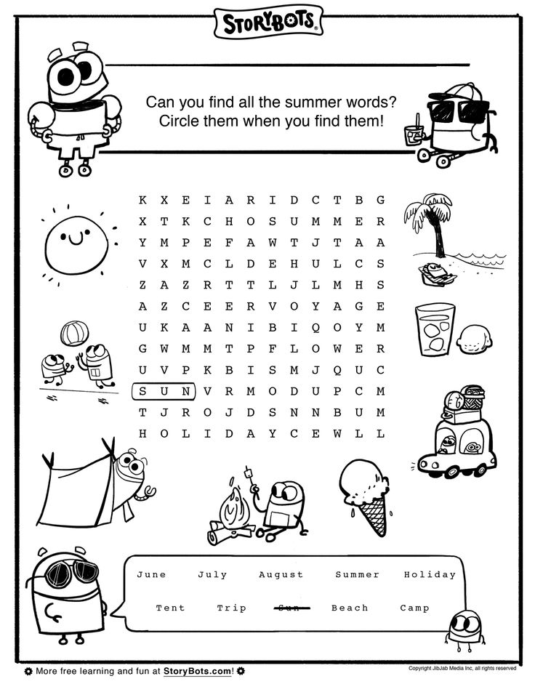

**Communion Servers**

**Altar Care**

**Page 8 of 8**

June – Cindy and Dan Klomp

**June Preparer**: Kelly Pauly

**Communion Servers:** Kelly Pauly & Sherrie Ingles

**Liturgists**

**Ushers & Greeters**

June 2 - Open

June 9 – Open

June 16 - Open

June 23 – Open

June 30 - Open

June 2 - Open

June 9 – Open

June 16 - Open

June 23 – Open

June 30 - Open

## Scripture Readings for June

**Sunday, June 2 Sunday, June 9**

**Seventh Sunday of Easter Pentecost Sunday**

Acts 16: 16-34 Acts 2: 1-21 or Gen 11: 1-9

Ps 97 Ps 104: 24-34, 35b

Rev 22: 12-14, 16-17, 20-21 Rom 8: 14-17 or Acts 2: 1-21

John: 17: 20-26 John 14: 8-17, (25-27)

**Breaking Chains Gathered and Scattered**

**Sunday, June 16 Sunday, June 23**

**Trinity Sunday Second Sunday after Pentecost**

Prov 8: 1-4, 22-31 1 Kings 19: 1-4, (5-7), 8-15a, and

Ps 8 Ps 42 and 43 or Isa 65: 1-9 and

Rom 5: 1-5 Ps 22: 19-28

John 16: 12-15 Gal 3: 23-29

**Wisdom Calls**  Luke 6: 26-39

**In God’s Presence**

**Sunday, June 30**

2 Kings 2: 1-2, 6-14 and Ps 77: 1-2, 11-20 or

1 Kings 19: 15-16, 10-21 and PS 16

Gal 5: 1, 13-25

Luke 9: 51-62

**Pick up the Mantle**

**St. James United Church of Christ**

**9008 Meisner Road**

**Casco, MI 48064**

**Phone:**

(586) 727--1623

**Fax:**

(586) 27-0833

**E-mail:**

kgadd@ourstjameschurch.org

We’re on the Web!

**Ourstjameschurch.org**



JUNE

NEWSLETTER

